Independent Plastic Application

September 15th, 2015

Contents

1 Scope of Work and Benefits 6

1.1 Overview of company 6

1.2 Overall goal of Work and Benefits 6

1.3 Overview of Business Processes 6

1.3.1 Overview of Purchasing Process 6

1.3.2 Flowchart of Sales Business Process 7

1.3.3 Overview of Purchasing Business Process 7

1.3.4 Overview of Inventory Business Process 8

1.3.5 Overview of Accounting Process 8

2 Data Concepts/Definitions 8

2.1 Business Relationships 8

2.1.1 Business Relationship Contacts 9

2.1.2 Call Logs 9

2.1.3 Call Back 10

2.1.4 Business Relationship Locations 10

2.2 Inventory Items 11

2.3 Purchase Orders 12

2.4 Transportation Orders 12

3 Forms 14

3.1 Login Screen 14

3.2 Sales 14

3.2.1 Customer Search 14

3.2.2 Customer Selection Form 15

3.2.3 Customer Edit Screen 17

3.2.4 Select Shipping Order Screen 17

3.2.5 Shipping Order Edit Screen 18

3.2.6 Sales Product Selection 20

3.2.7 Edit/Add Products to SO 23

3.2.8 Call Log 24

3.2.9 Call Back Screen 25

3.3 Purchasing 26

3.3.1 Select Purchase Orders 26

3.3.2 Create/Edit Purchase Order 27

3.3.3 Purchasing Product Selection 28

3.3.4 Purchasing Edit/Add Products 29

3.3.5 Set Min Level 30

3.4 Inventory 32

3.4.1 Select Purchase Orders 32

3.4.2 Select Existing Shipping Order Screen 33

3.4.3 Inventory Shipping Order Header 34

3.4.4 Inventory Product Selection 35

3.4.5 Inventory Add/Edit Products 36

3.4.6 Inventory Weights Screen 37

3.4.7 Inventory Reports 38

3.5 Reports 39

3.5.1 Report List 39

3.6 Admin 40

3.6.1 General Dropdowns 40

3.6.2 User Setup 41

4 Reports 42

4.1 Inventory Picklist / Shiplist 42

4.1.1 Description 42

4.1.2 Report 42

4.2 Transportation Order Labels 43

4.2.1 Description 43

4.2.2 Report 44

4.3 Transportation Order Shipping Label 45

4.3.1 Description 45

4.3.2 Report 45

4.4 Transportation Order Bill of Lading 45

4.4.1 Description 45

4.4.2 Report 45

4.5 Independent Plastics Certificate 46

4.5.1 Description 46

4.5.2 Report 47

4.6 Salesman Call Back Report 47

4.6.1 Description 47

4.6.2 Report 47

4.7 Purchasing Level Report 48

4.7.1 Description 48

4.7.2 Report 48

4.8 Accounting Invoice 48

4.8.1 Description 48

4.8.2 Report 49

4.9 Sales 18D: Gross Profit Report 50

4.9.1 Description 50

4.9.2 Report 50

4.10 INVSUM: Sum of Shipping Order Total Price by Ship Date By Salesman 50

4.10.1 Description 50

4.10.2 Report 50

4.11 MIKE1: Gross Profit By Customer and Salesman Report 51

4.11.1 Description 51

4.11.2 Report 51

4.12 CLEADING: Leading Customers by Sales By Volume 51

4.12.1 Description 51

4.12.2 Report 52

4.13 FRNKA: Sales to Individual Customers By Material 52

4.13.1 Description 52

4.13.2 Report 53

4.14 COGFIND: Material Shipped to Customer 53

4.14.1 Description 53

4.14.2 Report 54

4.15 INCOTT: Summary of the Cost of the Inventory in the Warehouses 54

4.15.1 Description 54

4.15.2 Report 55

4.16 INVCHK: Shipping Orders By Date 55

4.16.1 Description 55

4.16.2 Report 56

4.17 Row Report 56

4.17.1 Description 56

4.17.2 Report 57

4.18 Weight Report 57

4.18.1 Description 57

4.18.2 Report 58

5 Data Import 59

6 Testing and User Acceptance 59

7 Standards 59

7.1 Target user 59

7.2 Responsive design 59

7.3 Data grid filtering and sorting 59

7.4 Error handling 59

7.5 Formatting of fields 59

7.6 Operator Selections 60

7.7 Time Zones 60

7.8 Days of the Week 60

7.9 Calculated fields 60

7.10 Buttons 60

7.11 Preview and Print capabilities 60

7.12 Web Services 60

7.13 Azure Platform 61

7.14 Excel Connectivity/BI 61

7.15 Historical records 61

7.16 Drop downs and list boxes 61

7.17 Plus/Minus Icon 61

7.18 State Fields 61

8 Project Assumptions 64

8.1 Existing Technology Infrastructure 64

8.2 Production Infrastructure 64

9 Warranty 65

# Scope of Work and Benefits

## Overview of company

Independent Plastics is a leading source of quality grades of plastic pellets, specializing in injection molding products. Independent Plastics buys plastics from numerous suppliers and resells them to a variety of customers. One of the competitive advantages of Independent Plastics is its ability to provide high quality of service at competitive pricing. The dedication to high quality of service can be seen from the salesmen through the warehouse/shipping personnel. Building and maintaining the relationships with their customers and vendors is key to the company’s success.

## Overall goal of Work and Benefits

In 1994, Independent Plastics (IP) paid an IT company construct an application help the company integrate their processes and operate in a far more streamlined fashion. However, the business has changed over the past 21 years and the technology is not able to meet all of their business demands. The main goals that the client would like to achieve are:

* Modernize their current system into a web based solution.
* Upgrade the warehousing functionality to handle the greater complexity of the processes
* Greater financial reporting (i.e. dashboards, greater reporting and ad-hoc reporting)
* Integration with a Customer Relationship Management (CRM) and/or provide basic CRM capabilities
* Process Controls for sales, inventory management, purchasing and accounting

## Overview of Business Processes

The business is broken into four main business units: Sales, Purchasing, Inventory Control and Accounting. The sales team is responsible for maintaining customers and selling products. Purchasing is responsible for ordering any products which are needed to support the sales team. Inventory is responsible for maintaining the delivery and reception of products into the company. Accounting is responsible for ensuring that invoices.

### Overview of Purchasing Process

The decision to purchase a product may come from either inventory levels of certain products reaching a minimum, from a product pricing decision (i.e. management found a product at an attractive price) or driven from the sale of a product.

### Flowchart of Sales Business Process



### Overview of Purchasing Business Process

There are three ways that a purchase order is created.

1. A salesman requests that purchasing find a product for a sale
2. A given product reaches its minimum levels
3. Management finds a product at an attractive price which he/she desires

The purchasing department also needs the ability to set minimum levels on any and/all sets of parameters.



### Overview of Inventory Business Process



### Overview of Accounting Process



# Data Concepts/Definitions

Since many of the screens display the same data, it is necessary to define the data in business terms below.

## Business Relationships

The term customer is used to generically mean customer or vendor as the business relationship can be either or both. Therefore, customer and vendor are used interchangeably throughout the system.

Each business relationship will have the following data stored:

1. Business Relationship Identifier: Every business relationship will have a unique numeric identifier. This can be referred to as customer id or vendor id as well.
2. Business Name: This is the name of the company representing the business relationship. This name must be unique throughout the system. This can be referred to as customer name or vendor name.
3. Credit Type: This identifies the type of credit extended to this business relationship. Any business relationship will have only one credit extension.
4. Billing Information:
   1. Name: This is the name on the billing address
   2. Address Information: The address, address 2, city, state and zip will represent the billing address information
5. Web Site: This will be the URL of the business
6. UPS: This is a text string identifying the United Parcel Service number. This number allows Independent Plastics to charge transportation directly to the customer/vendor.
7. Active: This identifies if the business relationship is still active.

### Business Relationship Contacts

Each business relationship can have multiple contacts. Contacts are specific people at a company. Below is the information that will be collected for each contact:

1. Name: The name should be first and last name. As multiple people can have the same name, this combination of fields cannot be unique.
2. Phone Numbers: Each contact can have a multiple types of phone numbers (i.e. Mobile, etc.). This list of types should be as follows:
   1. Main
   2. Direct
   3. FAX
   4. Mobile
   5. Mobile 2
3. Contact Email: Each contact should have one contact email.

### Call Logs

This is meant to store information about the calls that were made by the users of the system. This should store basic information such as date and time of call along with the type of call (i.e. Product Search, Complaint, etc.) and a log of the call. This log should allow for quite extensive logging. The fields to store with respect to the call are:

1. User ID: This would be the user id of the person logged in when making the call
2. Call Type: This would be a lookup of items. Initially, it would start with General Call, Product Search, and Sale but the users would have the ability to add as they see fit.
3. Business Relationship: This should identify the business relationship for which the user is communicating.
4. Call Date and Time: This would be the calls date and time but it would default to the current date and time.
5. Call Log: This would be a field for them to enter all of the information about the call. This should allow for quite a verbose set of information.

### Call Back

This is meant to provide the user with the ability to log a time for them to call back in the future. The user would like this to be represented in a report by date instead of an email as they typically set many notes to call back and email would get quite cumbersome. The call back would have to have the below stated information:

1. Call Back Time and Date: This identifies the time and date of the call back.
2. Repeat Same Time Next Year: This identifies if the user would like to have this call back repeated for the same time every year.
3. Salesman(s) to Notify: This is a list of the users which will be included in the call back routine. This allows the user to allow multiple people to receive the same message. This is meant to allow the salesmen to notify other salesmen of important dates and times. For example, a salesman isn’t sure that he/she will be available at the call back time so he wants to ensure that other salesman call the specific customer on a specific date.
4. Call Back Message: This will be a message that will appear for the customer. This should allow for verbose language.

### Business Relationship Locations

Each business relationship can have multiple delivery and pickup locations. The location information should be as follows:

1. Name of location: This is a name given by the user. However, within the specific business relationship, the name of the location should be unique.
2. Address Information: The address, address 2, city, state and zip will represent the location address information
3. Location Definition: It must be noted that a location can be a pickup location, delivery location or both
4. Time of Operation: The user needs the ability to specify the operating times of the location. The locations are frequently only open during some times of the day and only certain days of the week. This information needs to be as follows:
   1. Time Zone: This specifies which time zone applies to the operating time. Each location can only have one time zone. This should be a list of all US time zones.
   2. Start Time: This is a time field (i.e. 09:00AM) which indicates the start time of the for the location.
   3. End Time: This is a time field (i.e. 05:00PM) which indicates the end time of the for the location.
   4. Days of Week: Each location can have multiple days of the week which it operates. By default it should be Monday through Friday. However, there are instances where the different days of operation such as only Monday through Thursday or Monday, Wednesday and Friday only.

## Inventory Items

Inventory items are the products that Independent Plastics purchases from its vendors and sells to customers. It must be noted that inventory items are frequently called products within Independent Plastics. It also should be noted that product also used to refer to a descriptor of an inventory item. Inventory Items are typically purchased from vendors in a group and may be parsed out and sold to multiple customers. For example, Independent Plastics may be 100 pounds of a given product from vendor X but sell 20 pounds of that product to customer Y and 80 pounds of that product to customer Z. The inventory items will have the below stated fields:

1. Form: Describes the type of form that the inventory items came in. These items would be descriptions such as Comp, Parts, Powder, Regrind, etc. A list of these items will be imported from the current Independent Plastics system.
2. Packaging: Identifies what type of packaging was used for the inventory items. This would be items such as Gaylord, Bags, Drums, Boxes, etc. A list of these items will be imported from the current Independent Plastics system.
3. Color: Identifies the color of the inventory item. This could be items such as Natural, Black, Clear, White, etc. A list of these items will be imported from the current Independent Plastics system.
4. Product: This is information such as ABS/ABS PC, etc. which is used to describe the inventory item. A list of these items will be imported from the current Independent Plastics system.
5. Notes: The inventory items can have some notes placed on it which describes the item in further detail.
6. Type: This is another description of the item.
7. Equivalent: This field is used to describe the item if it was used as an equivalent for another product.
8. Row: This is the row which the inventory items were placed.
9. Units: The number of units of packaging (i.e. 20 bags).
10. Quantity: This is the number of pounds of the product
11. Wholesale: The purchase price of the item
12. Reference: The reference number for the product. This should be able to accept alphanumeric values.
13. Internal Lot Number: Frequently, Independent Plastics gives the Inventory Items an internal lot number.
14. Vendor Lot Number: Frequently, the vendor gives the Inventory Items a vendor lot number.
15. Certificate: If an Internal Lot Number or a Vendor Lot Number has been entered, then a certificate may be attached to a set of inventory items. The certificate is a document describing the exact composition of the inventory items. This is a kind of validation of the inventory items.
16. Purchase Order Number: When the inventory items are purchased, there will be a purchase order identifier which should be attached to the inventory item. This will allow the user to track back to the actual purchase order from the purchase order.
17. Purchase Transportation Identifier: When a purchase order is generated, Independent Plastics must transport the inventory items purchased from the vendor directly to a customer or to one of its warehouses. This shipment will be included in a transportation order identifier.
18. Sale Transportation Identifier(s): When product is sold to a customer, it will receive a transportation order identifier.
19. Warehouse: This should indicate the Independent Plastics’ warehouse location. Currently, there are only two warehouses (Houston and Indiana) but this should be expandable to allow for Independent Plastics to add new warehouses.
20. In Transit To Warehouse: This should be a yes/no indicator of if the inventory items are in transit from the vendor to the warehouse.
21. In Transit to Customer: This should be a yes/no indicator of if the inventory items are in transit to the customer.
22. Received At Customer: This should be a yes/no indicator of if the inventory items are in transit to the customer.
23. Received In Warehouse: This should be a yes/no indicator of if inventory items are in the Independent Plastics’ warehouse.
24. Weights: When an inventory item is shipped, a series of weights will need to be logged which will identify the Control Number, Gross, Tar and Net weights of the inventory items. One inventory item can have multiple weights.

## Purchase Orders

Purchase orders (PO) are an order to purchase a given set of products from a vendor. This document only defines what products are to be delivered, from whom it was purchased, price of purchase and where it is to be delivered. It does not define how it gets there, cost of transport nor how the title of the product is transferred. This will be done on the transportation order and its related documents (i.e. Shipping Order, Bill of Lading, etc.). The purchase order will be described by the following items:

1. PO Number: This will be a unique numeric identifier given to the PO by the system. This will be used to identify the PO with Independent Plastics’ vendors
2. Contact: This is the contact from the business relationship that is used for this PO.
3. Accounts Payable Contact: If a business relationship contact with a type of “Accounts Payable” has been identified, it will be identified here.
4. Date for Pickup: This is a date and time field which indicates the date all of the products purchased are ready for pickup. This is used such to inform the inventory control personnel when the freight should be ordered such that the item will be picked up on time. Most commonly, this is the subsequent day and, as such, it is defaulted to the subsequent day.
5. Estimated Delivery to Warehouse/Customer: This is a date and time field such indicating the time communicated to the warehouse and customer as to when the product should be in the expected in the warehouse or the customer.
6. Released to Be Sold: This is a yes/no field which indicates to the sales and inventory personnel that the items on the PO are ready to be sold and/or shipped. This is meant to give the purchasing agents time to complete the PO prior to anybody else selling or shipping the items.
7. Inventory Items: This will be a list of inventory items which will be shipped in accordance with the PO.

## Transportation Orders

As shipping orders and bills of lading contain much of the same information, the term transportation orders is meant to describe the information on both the shipping order and bill of lading. A transportation order is simply an order to ship inventory items from one place to another. However, it must be noted that the term shipping order and transportation order are used. The fields below describe a transportation order:

1. Transportation Identifier: Unique numeric identifier which identifies the inventory items
2. Business Relationship: This will identify the customer from which this transportation order is being sold to or the vendor which this transportation order is being sold to.
3. Salesman: This identifies the salesman who is selling this transportation order to a customer. This should be defaulted as the user id. However, there are times when one salesman is selling for another salesman so this value needs to be changed.
4. Business Relationship Location: This is the location which the product is being picked up at or the location which the product is being delivered to.
5. Credit Terms: Although this will default to the credit terms which are specified by the business relationship, a salesman should be able to change this.
6. COD Fee: This is a numeric amount for the fee related to the COD (Cash on Delivery).
7. Freight Charges: This is a numeric amount indicating the freight charges applied to the inventory items on the transportation order
8. Ship Date: This is the ship date of this transportation order. This cannot be any less than the last date of pickup from the inventory items on the originating purchase order. This can be set to after this date than this but not earlier. Please remember that all items being sold must but purchased and, therefore, all inventory items will have a date of pickup from their respective PO.
9. Preferred Carrier: This is carrier selection from the list of carriers. This list of carriers will be retrieved from the Independent Plastics application
10. Total Weight: This is the total weight of the inventory items in the transportation order. By default, this is calculated from the sum of the net weights of all inventory items in the transportation order. However, this number needs to be editable as there are times where the sum of the weights needs to be adjusted based on business decisions.
11. BOL Instructions: This is a large text field which allows the user to put specific instructions to appear on the bill of lading.
12. SO Instructions: This is a large text field which allows the user to put specific instructions to appear on the shipping order.
13. Shipping Order Printed: This is a yes/no field indicating if the SO has been printed.
14. Bill of Lading Printed: This is a yes/no field indicating if the BOL has been printed.
15. Received in Inventory: This is a yes/no field indicating that the entire transportation order has been received. When this is selected, all inventory items on the transportation item are also logged as received in inventory.
16. Type of Transportation Order: There are three types of transportation orders: Sale, Purchase and Return. If this is a return (i.e. the customer finds the items on the inventory item unacceptable), the below stated items become relevant.
17. Return Type: If the transportation order is a return, then the type of return should be noted. The return can be Return to Vendor, Used For Resale or Disposed of. Frequently, the vendor will not accept the returned product. In this event, the returned product is either resold to a customer or disposed of. This depends on the quality of the return.
18. Inventory Items: This is a list of the inventory items on the transportation order including the quantity to be shipped. It must be understood, the transportation items need to have been purchased before being move to the warehouse or to a customer. In other words, in order to place an inventory item(s) on a transportation order, it would have had to been on a purchase order.
19. Inventory Person In Control: This logs which inventory person is working on this transportation order and/or the last person to be in control of it. This would be the user id of the inventory person in control of the item.

# Forms

## Login Screen

The screen below will be representing the initial login screen. All users will need to log in to the system with an id that will be created via the Admin->User Set up screen.

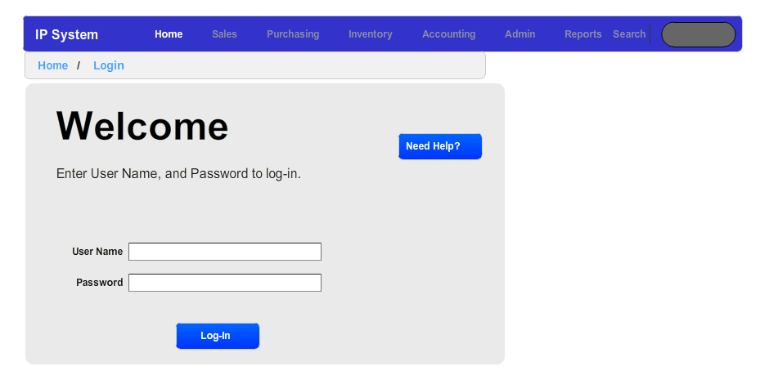

## Sales

The purpose of these screens is to allow the salesmen to maintain customer information, find available inventory items for customers and initiate the transportation order to get sale to the customer. Once the salesman has finished with the transportation order, he/she will release the transportation order to the inventory personnel to ensure the proper transportation of the inventory items.

### Customer Search

This form is used to search for a specific customer. The search should follow the below stated rules

1. All text boxes are searched on wildcard basis and should not be case sensitive. This wildcard basis should be both before and after (i.e. %abc%).
2. List/Combo boxes (i.e. Credit List Box) should be a mult-select.
   1. If nothing is selected, then the list box is ignored.
   2. If only one item is selected, then the search routine will return where the referenced item (i.e. credit level) is equal to the selected value. For example, if only Net 30 is selected, then the search will return those values where business relationships have a credit rating of Net 30.
   3. If more than one value is selected, then the search routine will return where the referenced item (i.e. credit level) is equal to one of the selected values. For example, if only Net 30 and Net 60 is selected, then the search will return those values where business relationships have a credit rating of Net 30 or Net 60.
3. Uses Check Box: In some items, a check box was placed to indicate if this would be search criteria would be used or not. For example, searching the call log for dates requires a check box to indicate if this would be used or not.

#### Specific Fields That Need Description

1. Last Call Search: This searches the call logs for any date and time according to the operator list box. For example, if the user were to put in 12/15/2015 09:00AM and less than or equal to, the system would search for all calls prior to or equal to 12/15/2015 at 9AM.
2. Last Call Back Search: This searches the Call Back for any date and time according to the operator list box. For example, if the user were to put in 12/15/2015 09:00AM and less than or equal to, the system would search for all calls prior to or equal to 12/15/2015 at 9AM.
3. Call Person should be a multi-select list box and should have a list of all users. If used, this would refer to returning any customers called by the selected person(s).
4. Days of Week: This search would return any items with selected days falling within their respective days of operations. For example, if a business relationship had days of operation of Monday through Friday and the user selected Monday only, the system would still return this customer as Monday is within the business relationship’s day of operation

#### Buttons

**Clear Button**

If the clear form is pressed then, all text boxes are cleared and all multi-select list boxes are deselected (i.e. nothing is selected.)

**Search Button**

If the search screen is pressed, then the results of this search would be seen in the customer selection screen.

##### Search Screen

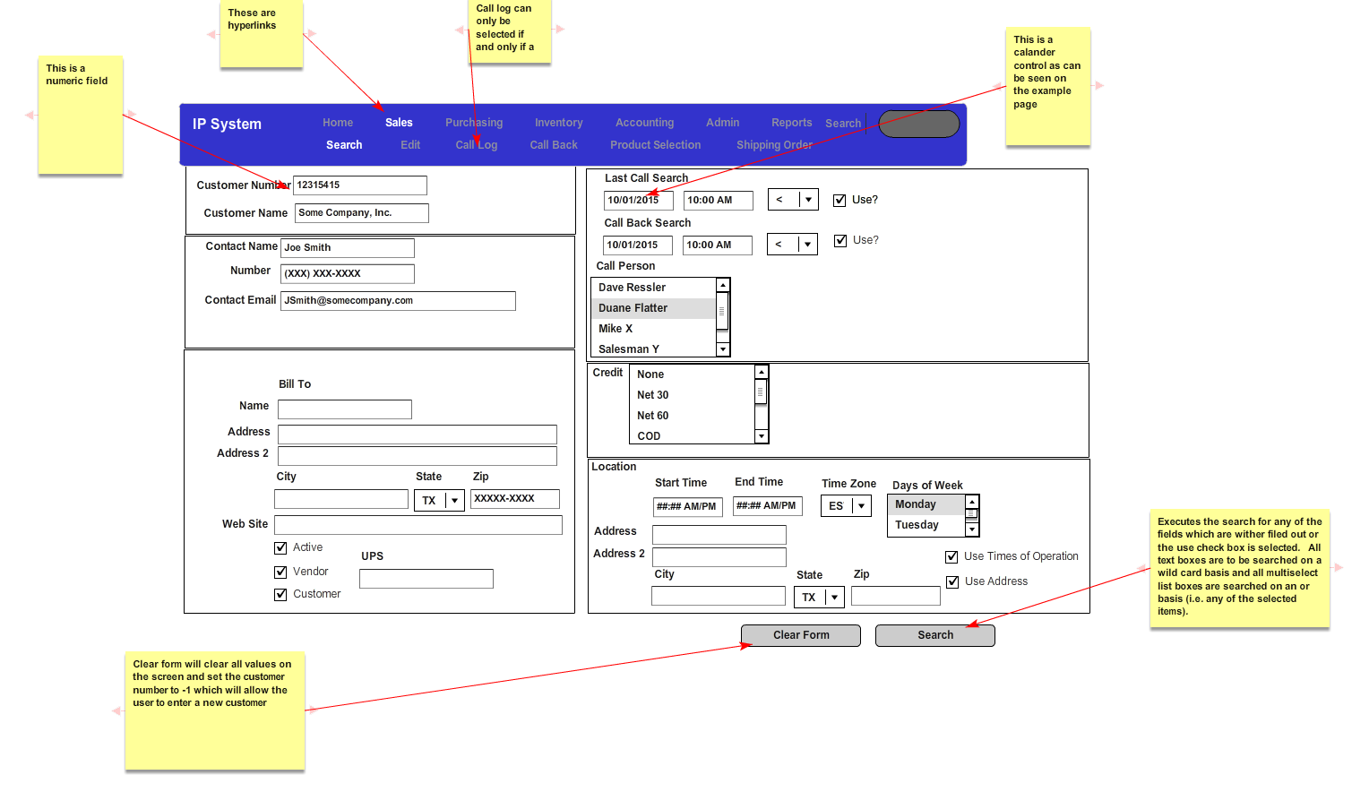

### Customer Selection Form

This is a grid based on the results of the previous customer search form. The grid would contain the Customer Name, list box of contacts for the customer, contact phone number, contact city, contact state, salesman who conducted the last sale.

#### Buttons

If the cancel button is pressed, the user is returned to the customer search screen.

If the confirm button is pressed, the use is sent to the customer edit screen with the respective customer data filled in.

#### Form

The grid would contain the Customer Name, list box of contacts for the customer, contact phone number, contact city, contact state, salesman who conducted the last sale (if available).

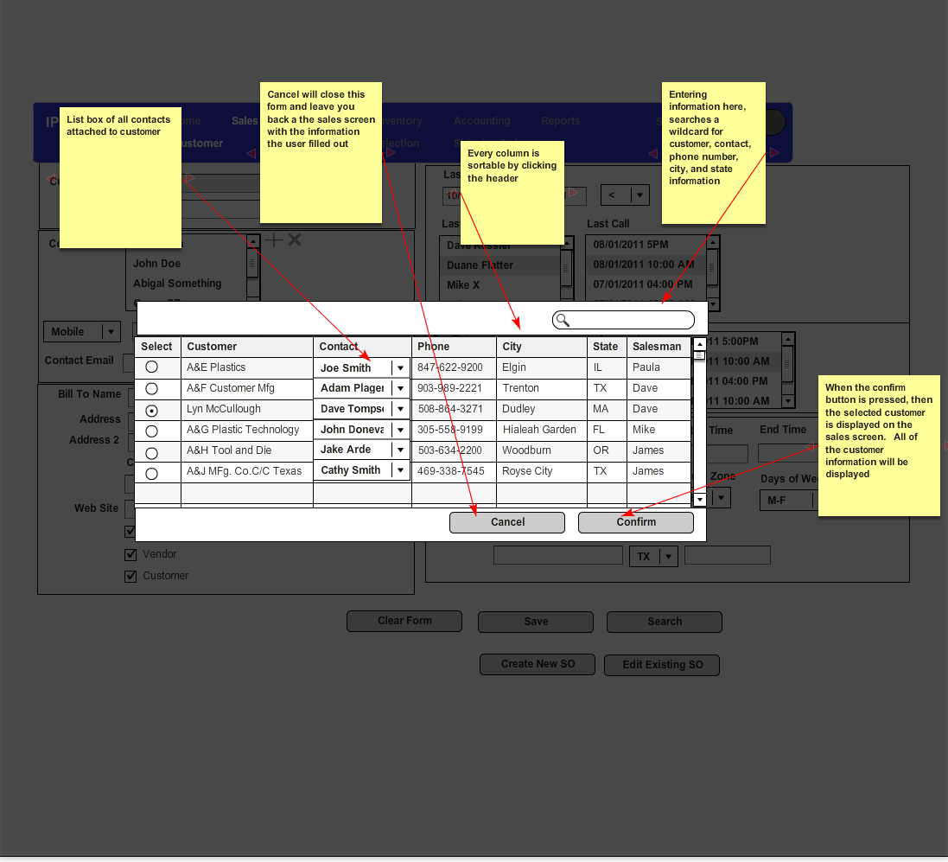

### Customer Edit Screen

This screen allows the user to create a new customer or edit existing information. If the user enters this screen based on a search from the customer search screen, the related business relationship information will be filled in by default. If, however, user simply enters the link via the “Edit” link, the system assumes the user is attempting to enter a completely new customer and no information is filled out.

#### Buttons

1. The delete button will delete the existing business relationship if and only has not purchased products from or sold products to Independent Plastics. If this is the case, Independent Plastics is only allowed to make the business relationship inactive.
2. Clear Form: The clear form is meant to allow the user to enter a completely new business relationship. Therefore, this button will clear all information on the screen.
3. Save: This will save the current information for the business relationship.
4. Create New SO: This will create a new transportation order and send the user to the “Shipping Order” screen under the sales menu selection.
5. Edit Existing SO: This button will display the search existing Shipping Order Selection screen based on the customer information in this screen

#### Form

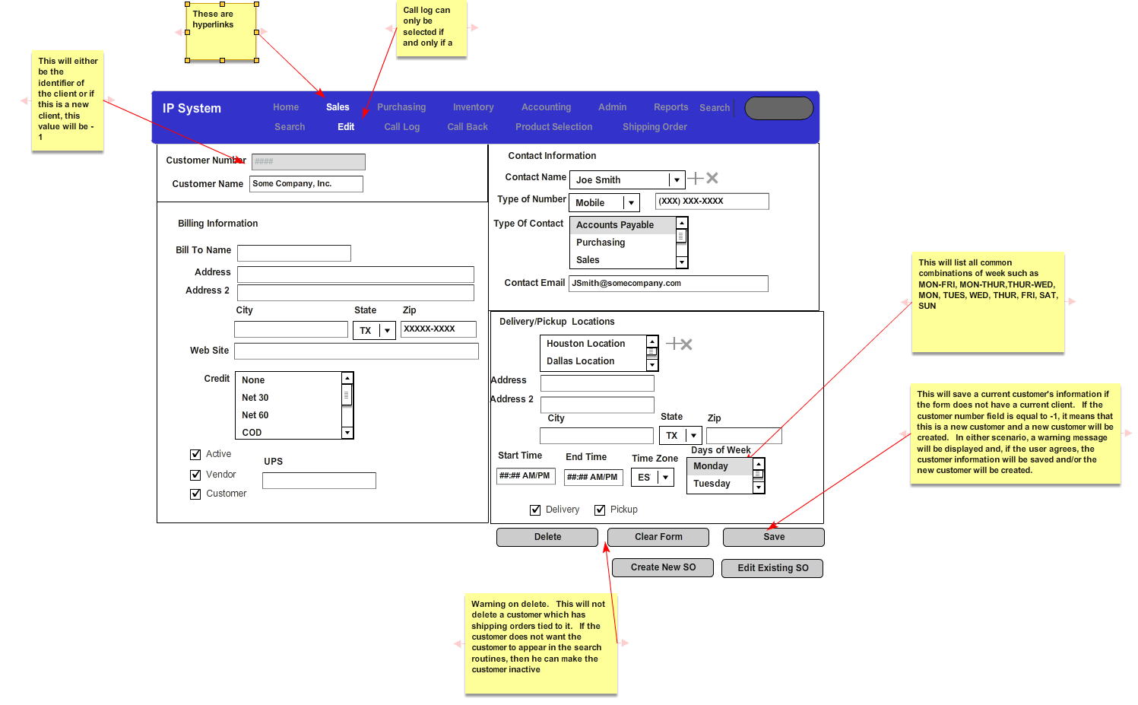

### Select Shipping Order Screen

Based on the selected customer, this screen will display all shipping orders (i.e. transportation orders) shipped to this business relationship. By default, the grid will be sorted in descending order by ship date.

#### Buttons

1. Cancel Button: This will close the screen and return the user to the customer edit screen.
2. Confirm: This button will take the customer to the shipping order edit screen with the selected shipping order selected

#### Form

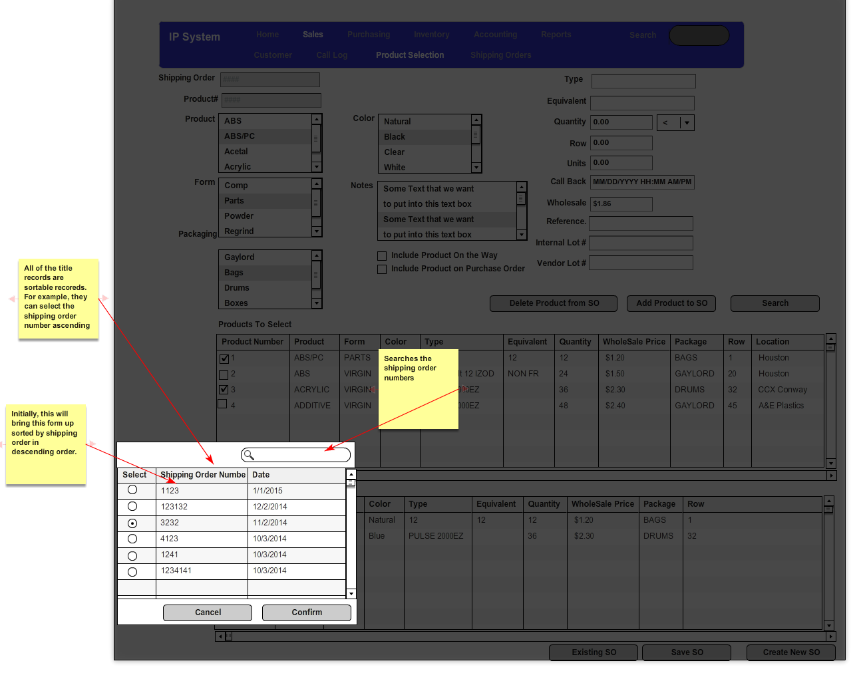

### Shipping Order Edit Screen

This screen is for creating the transportation orders in order to create shipping orders and bills of lading to transport products from either the vendors to the customers or from the warehouse to the customers. However, all of the transportation orders on this screen are always used to deliver products to a customer

#### Fields

1. Amount: This is the sum total of the products multiplied by the sale price on the shipping order. If no products have been selected, then this field is 0.
2. Customer Location: The user will select one of the customer’s location which the products will be delivered to.
3. Pending: When the salesman is ready to finalize the transportation order and have inventory ship the product, he will check the pending checkbox to unchecked. This allows the user to work on a transportation order and only send it to the appropriate people when he/she is finished with the order.
4. Freight Paid: This is the freight terms based on terms entered by the users. This information will be extracted from the existing system but the users should have the ability to add items to this list.
5. Ship Date: This is the ship date and time of the shipment. This shipment will have a ship date no earlier than the latest available product. For example, if the shipment has 2 products and one is available to ship tomorrow but the next product isn’t available for a week, the earliest that this ship date can be is in a week. This is a required field.
6. Products Grid: This is a grid of all products already on the shipping order. The only field editable on this grid will be the rename field.
   1. Control Number: A number given to the group of inventory items being selected. Each new group of inventory items being purchased will receive a new control number.
   2. Rename: Text field which the user can enter to rename the product on the shipping order, bill of lading, labels and invoices. This is for display purposes only. If this is left blank, then it is assumed that no renaming is necessary.
   3. From Location: The current location of the inventory items.
   4. Quantity: Number of inventory items within this group being purchased.
   5. Cost: Sale Price of the Inventory Item Group.
   6. Inbound Freight: Freight Cost Associated with this group of Inventory Items.

#### Buttons

1. Create Shipment Email: This creates the shipment email for the salesman. This email will produce a simple text box detailing the shipment date and a list of products to be sold. The user will then copy this information into his/her own email. The salesman have specifically requested that the system not send this email directly to the customers as they want to maintain control of this aspect of the communication.
2. Product Selection: This will take the user to the sales product selection screen within the sales screen.
3. Delete Shipping Order: This will delete the shipping order if and only if it has not been locked by the inventory personnel. If it is locked by the inventory personnel, the salesman will have to request the inventory personnel unlock the shipping order. This is to prevent the deletion of sales that have already shipped from Independent Plastics. If the transportation order has already been shipped, then it cannot be deleted by the salesman.
4. Save Shipping Order: This saves all header information on the transportation order and any of the renaming of the products.

#### Forms

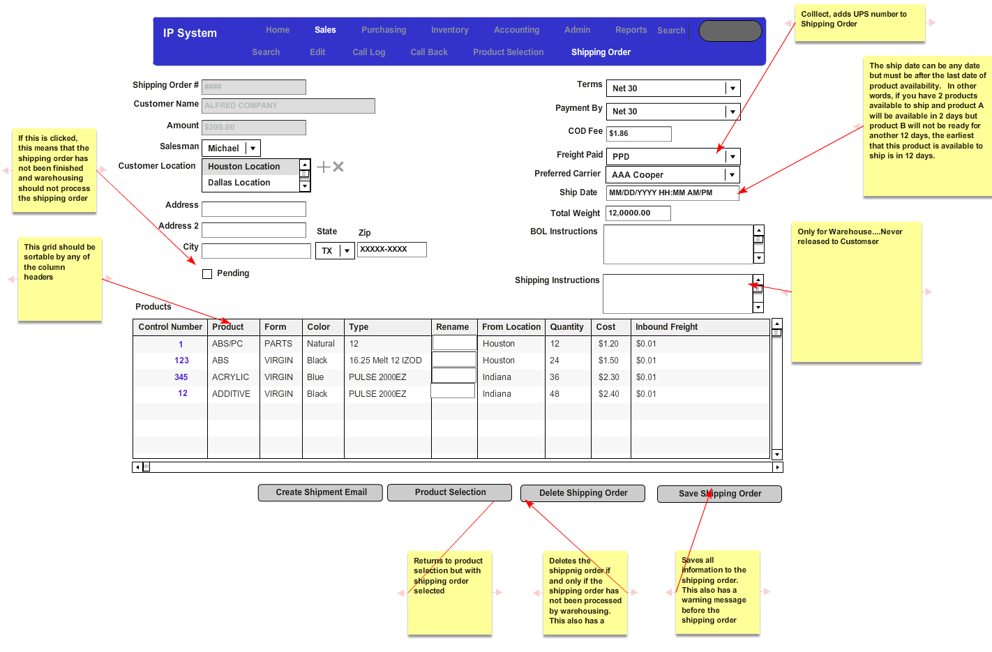

### Sales Product Selection

#### Main Description

This form is meant to allow the salesman to search inventory, select for inventory items and place these inventory items on a shipping order (i.e. transportation order). Thus, this screen has three parts.

1. Search Screen for Inventory Items
2. Results of the Search for the Inventory Items
3. Inventory Items Already On Transportation Order.

#### Search Portion

1. All text boxes are searched on wildcard basis and should not be case sensitive. This wildcard basis should be both before and after (i.e. %abc%).
2. List/Combo boxes (i.e. Form or Color List Box) should be a mult-select.
   1. If nothing is selected, then the list box is ignored.
   2. If only one item is selected, then the search routine will return where the referenced item (i.e. credit level) is equal to the selected value. For example, if only Natural is selected, then the search will return those values where inventory items have a color of Natural.
   3. If more than one value is selected, then the search routine will return where the referenced item (i.e. color) is equal to one of the selected values. For example, if only Natural and Black are selected, then the search will return those values where business relationships have a color of Natural or Black.
3. Uses Check Box: In some items, a check box was placed to indicate if this would be search criteria would be used or not. For example, searching the call log for dates requires a check box to indicate if this would be used or not.
4. Quantity: The quantity is the sum total of the inventory items.
   1. If the check box “Include Product On The Way” is checked, the quantity would also include all inventory items in transit from the vendors to the warehouses. Conversely, if this is unchecked, it would exclude those items in on the way. The default for this should be unchecked.
   2. If the check box “Ordered But Not Shipped” is checked, the quantity would include all inventory items on a purchase order but that have not shipped yet. Conversely, if this is unchecked, it would exclude those items in the on a purchase order but have not shipped. The default for this should be unchecked.
   3. If the check box “In Warehouse” is checked, this would include all items in the ware house. Conversely, if this is unchecked, it would exclude those items in the warehouse. The default for this should be checked.

#### Search Results

This grid would display the results of the search. The quantity would the total items which fit the selected criteria that have not been shipped to a customer. The available items are the items which area not on a transportation order for a given customer. This distinction is important as the salesman will frequently put items on transportation orders as a way of holding the inventory for customers even if they do not have a sale for the inventory. In the event that this happens, the other salesmen need to know so they can negotiate with the salesman holding the inventory.

#### Fields

1. “Include Products On the Way”: If this is checked, then the search will also include those products which have not arrived in the Independent Plastics’ warehouses but have already shipped from the vendors. The default for this is to be checked.
2. “Ordered But Not Shipped”: If this is checked, then the search will include those products which are on a purchase order but have not shipped yet from the vendor yet. The default for this is to be checked.
3. “In Warehouse”: If this is checked, then the search will include those products which are in any of the Independent Plastics’ warehouses. The default for this is to be checked.
4. Quantity:
   1. Text Box: This is an integer only text which must be greater than or equal to 0. It defaults to 0.
   2. Dropdown Box: This is a dropdown of all of the operators
   3. “Uses” Checkbox: If this is selected, then the search will apply the combination of the number in the text box and the operator in the dropdown to the quantity available in the warehouse. Please note that this is note the quantity in the warehouse since these two numbers can be different. The quantity in the warehouse is the amount physically in the warehouse but the quantity available is the amount in the warehouse minus the quantity of the specific product on shipping orders sold to customers.

#### Products to Select Grid Box

This grid box houses the results of the search routine from the selections above. From this grid box, they user can select the items and move them to the shipping order (i.e. transportation order).

#### Products In Shipping Order

These are the items that are already on the shipping order (i.e. transportation order). The radio button allows the users to select individual line items to edit and/or remove from the shipping order. To be clear, the items here are the same as the grid on the sales shipping order header page.

#### Buttons

1. Who’s Holding: The purpose of this button is to allow salesman to see the products are on the shipping orders but that have not shipped yet. This button would display a grid box which displays, the shipping order number, salesman which have these products and ship date. The shipping order number would be a hyperlink which would take the user to the shipping order header screen under the sales screen. If the user has not saved his/her current data, a warning would appear.
2. Search: This button would apply the search parameters which have been selected and fill in the products to select grid box.
3. Add Product to SO: This button would display the “Add/Edit Product to SO”
4. Edit Product on SO: This brings up the “Add/Edit Product to SO” page with respect to the selected item in the Products on Shipping Order grid. In other words, the quantity to order field is from the quantity in the Products in Shipping Order grid.
5. Delete Product from SO: This will remove the selected item from the Products in Shipping Order. When the user executes on this action, the system will add the selected product back into inventory and thus will add to the available field on the Products to Select portion of the grid.
6. Existing Shipping Order: This will bring up existing shipping order header page. However, it will warn the user if the user has not saved his current work to an existing shipping order.
7. Save SO: This will save the products to the selected shipping order. If the user has not created a shipping order, the system will not allow him to save.
8. Create New SO: This take the given products in shipping order, create a new shipping order and send the user to the shipping order header page with the current customer selected.

#### Form

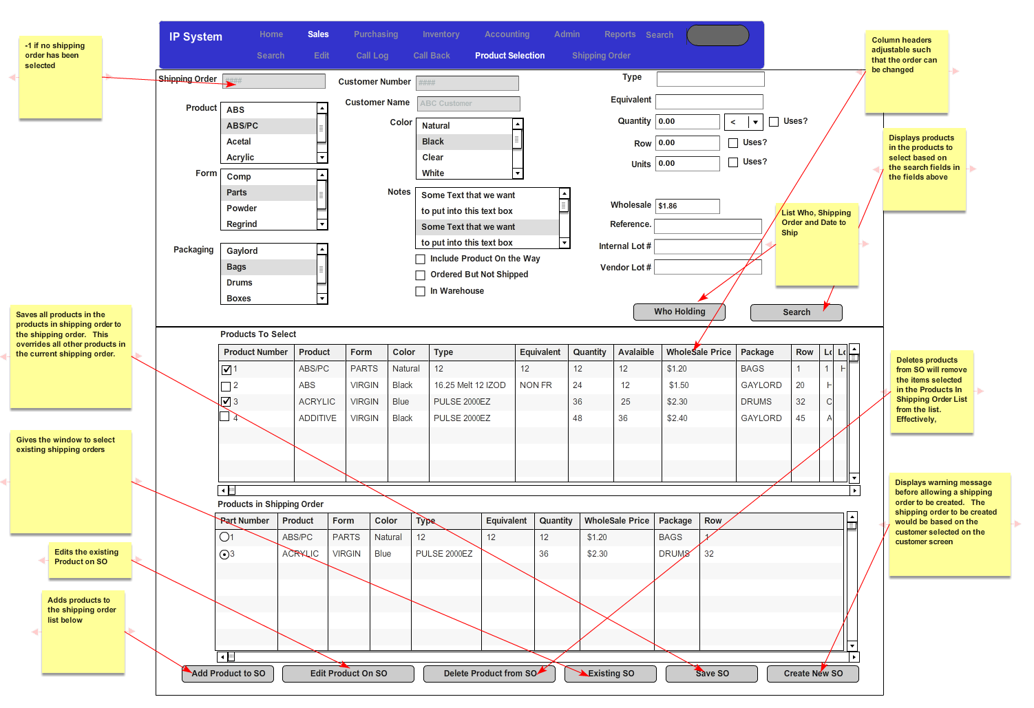

### Edit/Add Products to SO

This form is made to add or edit inventory items being placed on a shipping order.

#### Fields

1. Type of Sale: This is a list of all records in the lookup table of type of sales. This is a required field. The current types of sales would be N/A, First Time Sale, and Continuing Sale.
2. Warehouse/Vendor Radio Button: If the inventory items are at the warehouse or already on route to the warehouse, the product will only be available at the warehouse and this will be disabled with warehouse selected. If the product is still at the vendor, the salesman can choose to pick up the product from the vendor or from the warehouse.
3. Name of Document: The users may need the ability to attach a single document to the product. The text field is a name given to the document. This is not a required field
4. Quantity Available is the available field from the products to select grid. This is not editable.
5. Quantity to Order: This is the quantity that the salesman wants to ship. It must be less than or equal to the quantity available.
6. Price is the sales price of the inventory items. It must be noted that this needs to be greater than or equal to 0.

#### Buttons

1. Cancel: This button cancels the changes and simply returns the user to the sales product selection screen
2. Confirm: This button will adjust the available column of the products to select grid and add the items to the products to shipping order grid. This would also add the inventory items to the transportation order.

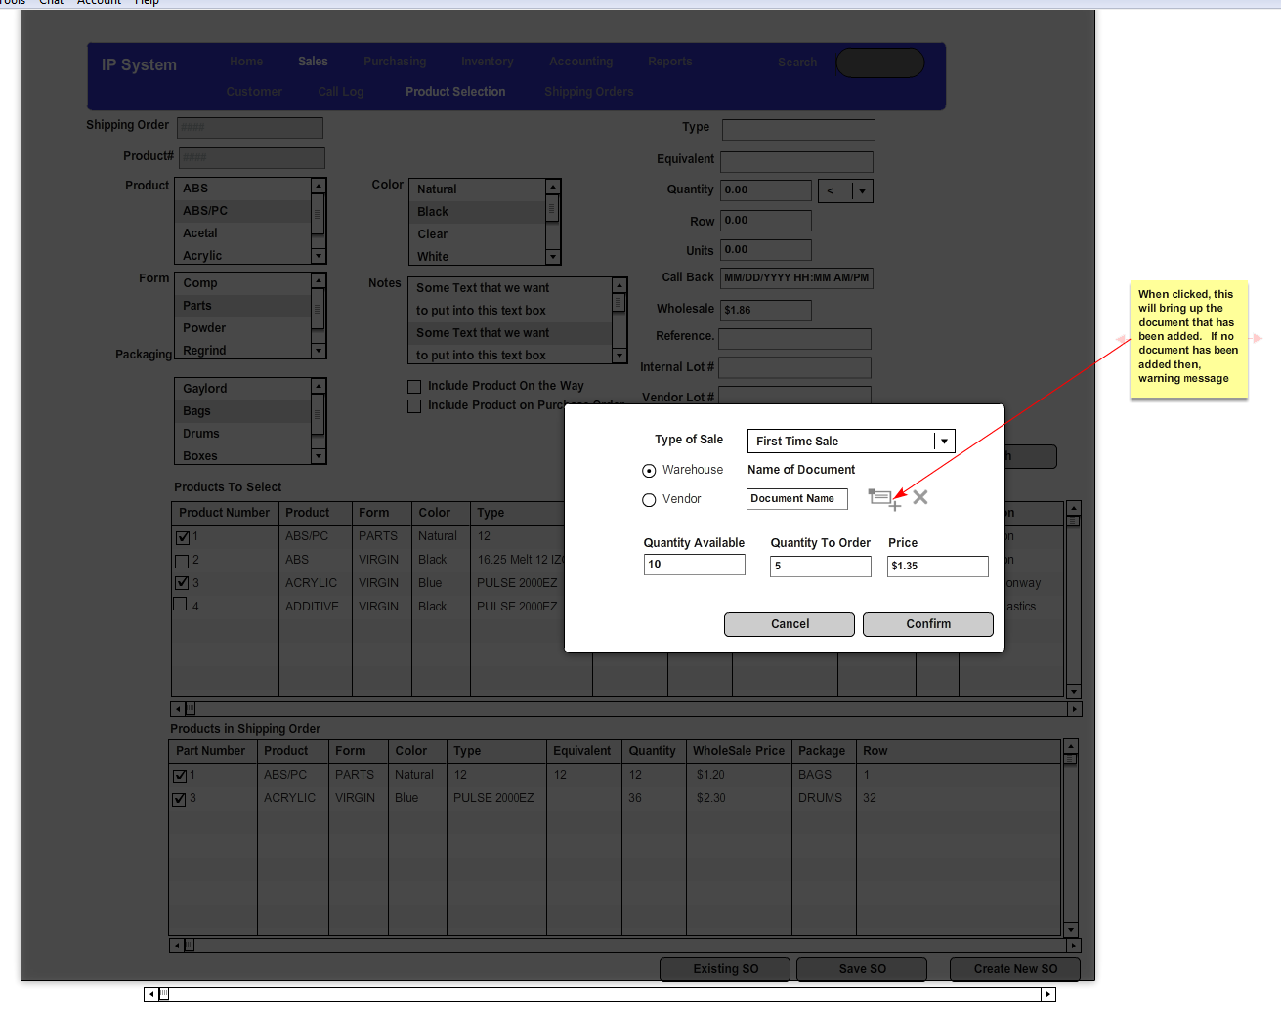

### Call Log

Through this system, the user is able to edit, delete and add calls to the selected customer associated with the user’s id. The call time list box is a single select list box displaying all of the calls made by the user. If the user chooses not to fill this out, he can either go to the call back or the product selection screen by simply choosing the call back or product selection menu items.

#### Fields

1. Call Time List Box: This is a list box of all calls made by the user to the customer. If an item is selected in this list box, the call time text box and call log text box will be filled in with the call time selected. Additionally, the call type list box will have all items selected for this call time.
2. Call Type: This is a list box of the available call types. Initially, this will have the values of Pricing, Purchasing, Discuss Business and Product Feedback. However, this will be editable via the admin screens.

#### Buttons

1. Clear Form: When the user presses this, the screen is cleared of all selected items.
2. Delete: Deletes the current call log.
3. Save: If a call time has been selected, then this saves to the selected call time. If no call time has been selected, it is assumed that this is a new call and a new call log is saved.

#### Forms

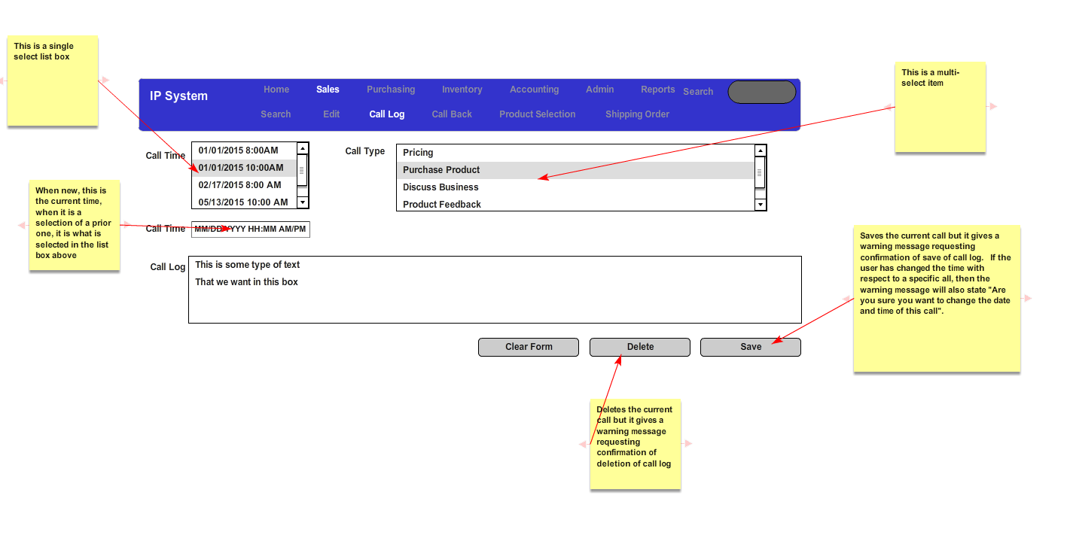

### Call Back Screen

This screen will allow the user to enter a call back time into the system which will user to enter call back dates and times along with who should be notified and a text message. This system will email the users selected in the sales man to notify on that specific date/time with a subject of “Email Notification” and the body consisting of the call back message.

#### Fields

1. Call Time List Box: This is a single select list box which the user can select of any call backs that have been saved for this customer
2. Salesman to notify: This lists all users in the system. By default, this will select the user currently logged in. At least one selection is required.

#### Buttons

1. Clear Form: This will unselect the call back and the salesman to notify list boxes. It will also clear the date/time and call back message boxes. This button is required to enter a new call back message.
2. Delete: This will delete the selected call time. A warning message will appear before the system deletes the record.
3. Save: This will save the current record. If no call time has been selected, the system assumes that this is a new record. If an existing record is selected, then the system assumes that this references the currently selected record. In both cases, the system warns the user before allowing the save to continue.

#### Forms

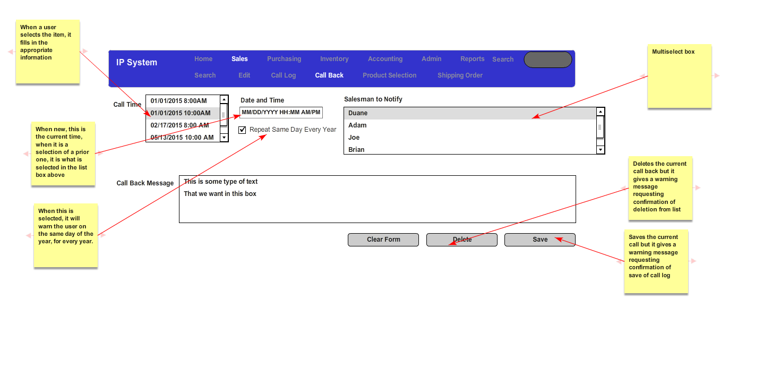

## Purchasing

This screen is what allows the purchasing agents to create purchase orders and ensure that products have been purchased. Once the purchase order has been created and released, the purchase order goes to the inventory personnel to get the inventory items transported and received into Independent Plastics. There is only one exception to this process and that is when a product is to be shipped from the vendor directly to the customer. In this instance, the transportation order is actually initiated by the salesman and, ultimately, finished by the inventory personnel.

### Select Purchase Orders

#### Fields

1. Radio Buttons:
   1. Purchase Orders without Shipping Orders: If this is selected, the system will select any purchase orders which have products that are not on a shipping order.
   2. Purchase Orders with Shipping Orders: If selected, the system will select all purchase orders which all of the products have been placed on a shipping order.
   3. All Purchase Orders: If selected, the system will select all purchase orders regardless of the status of the underlying products.
2. Start Date: Date Field which defaults to the current date minus one day. This date pertains to the purchase order date. This is a required field.
3. End Date: Date Field which defaults to the current date. This date pertains to the purchase order date. This is a required field.
4. Purchase Orders to Select:
   1. PO Number: Numeric identifier assigned to the purchase order.
   2. Vendor: Vendor Name from the purchase order.
   3. Date Ready: Date which all of the products on purchase order will be ready. To be clear, this will be the date which the last product is to be available.
   4. Delivery Location: This is the location which the products will be delivered on this purchase order.

#### Buttons

1. Search: Given the fields selected, the system will search the purchase orders and return all search orders in the “Products to Select” grid box.
2. Edit Purchase Order: The system will open the create/edit purchase order screen with the selected purchase order selected.
3. Create Purchase Order: This will open the user to create/edit purchase order screen with no purchase order.

#### Forms

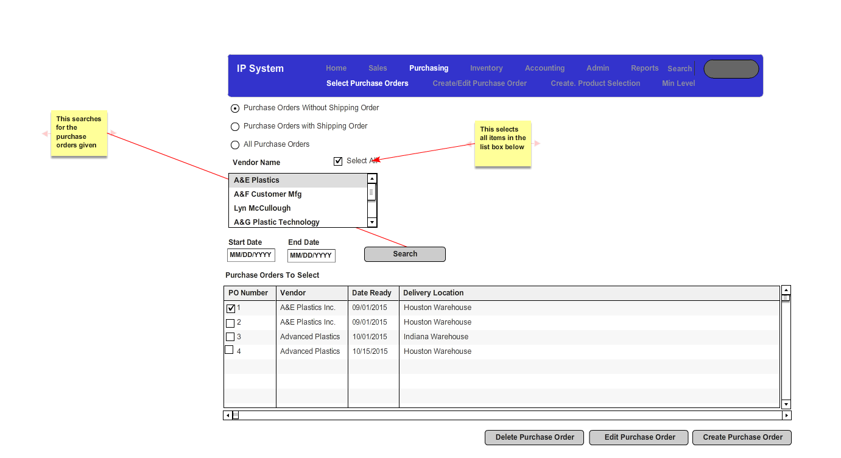

### Create/Edit Purchase Order

From this screen the user will either edit an existing purchase order or will create an entirely new purchase order. The determining factor is what button they have pressed

#### Fields

1. Accounts Payable: This is the first contact in the accounts payable department. This is meant to ensure there is someone to contact in the accounts payable department when the product is purchased.
2. Salesman: If this purchase order is being created in order to fulfill a particular sale for a salesman, then the salesman is selected. If not, then this will be N/A. The default is N/A.
3. Release To Be Sold Checkbox: This releases this purchase order to the salesmen. By default this is unchecked.

#### Buttons

1. Delete the Purchase Order: If a shipping order has been attached to any of the products on this purchase order, then this is disabled.
2. Save Purchase Order: This will save all items on the existing purchase order. If this is a new purchase order, then the system will automatically add the purchase order.
3. Edit Products: This will bring the user to the product selection portion of the purchasing screen.

#### Forms

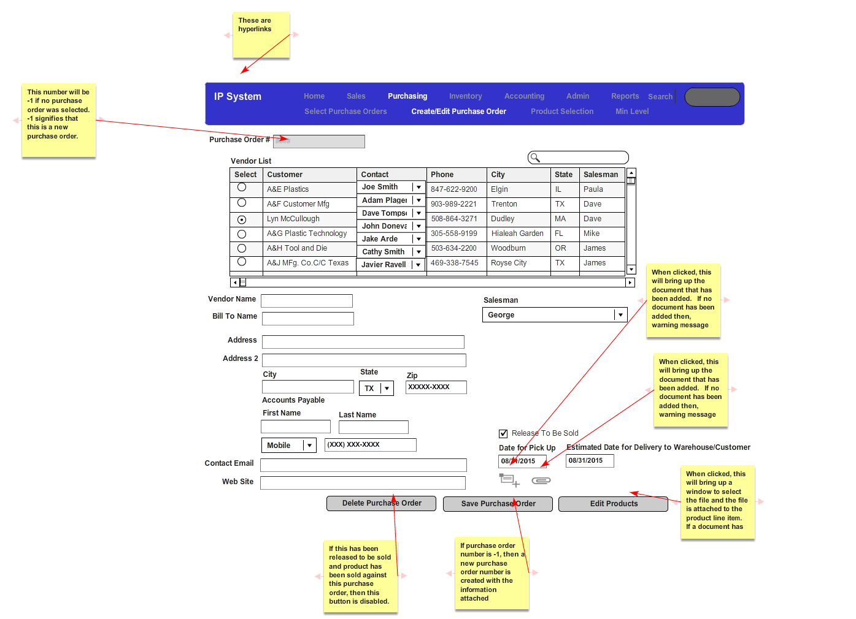

### Purchasing Product Selection

#### Fields Needed to Describe

All list boxes should be single select as each inventory item (i.e. product) being added to the purchase order is one set of inventory items.

1. Quantity: This is a numeric field of the amount of the product being ordered. This is a required field.
2. Wholesale Price: This is the wholesale price of the product being ordered. This is a required field and must be greater than or equal to 0.
3. Release To Be Sold Checkbox: This releases the entire purchase order to the salesmen. By default this is unchecked.

#### Buttons

1. Edit Product On Purchase Order: This will display the “Purchasing Edit/Add Product Number” for the selected line item in the “Products in Purchase Order” grid.
2. Delete Product from Purchase Order: This will delete the product from the purchase order
3. Add Product to Purchase Order: This will display the “Purchasing Edit/Add Product Number” for the product described by the parameters above the grid.
4. Save PO: This will save the products to the purchase order along with the “Release to be Sold” checkbox information.

#### Forms

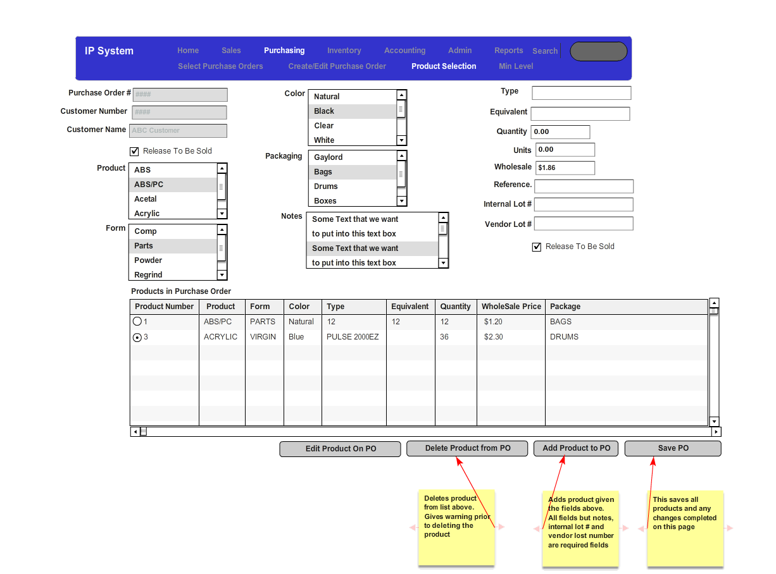

### Purchasing Edit/Add Products

This screen is meant to allow the user to add and/or edit inventory items on the purchase order. This is also meant to allow the user to create and add certificates purchase order.

#### Buttons

1. Cancel: Does not update and only closes the existing form.
2. Confirm: Saves the information on this form to the purchase order and closes the existing form
3. Create Certificate: This creates the Independent Plastics Certificate (Please see reports) and saves this as a PDF to the inventory items on this purchase order.

#### Form

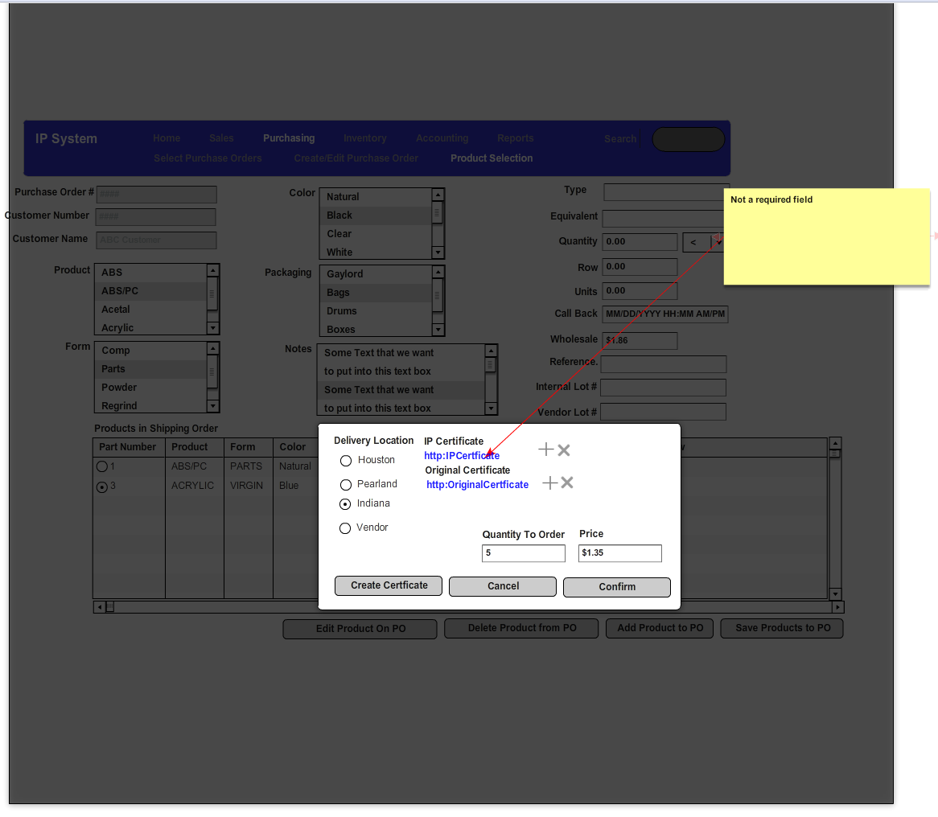

### Set Min Level

The purpose of this screen is to allow the user to set minimum levels for specific inventory items so that the salesmen always have enough of commonly sold products. As some products are somewhat interchangeable, the user needs to be able to define a very specific product but also a very broad set of parameters. For example, the user may only want to set a minimum level of natural colored inventory items. He/she may also want to be able to define a minimum level for ABS, COMP, Natural, Bags with type = “XYZ”. Although emailing when a minimum level was discussed, the Purchasing Personnel wanted to receive a report of this and not an email. Please see the reports section for this report.

#### Fields

1. List Box of Names: This is a list box of all available warnings that have been inserted.
2. Text Box of Name: If a given name has been selected, this will equal the given name. Deselects all names, then this becomes a new name.
3. Product: A single-select list box of the lookup table of products (please note this is the parameter). This is a required field.
4. Form: A single-select list box of the lookup table of forms.
5. Color: A single-select list box of the lookup table of colors.
6. Packaging: A single-select list box of the lookup table of packaging.
7. Type: This is a text box of type information for the product.
8. Equivalent: This is a text box of the equivalent information for the product.
9. Quantity: This is a numeric field of the amount of the minimum level. This is a required field.
10. Dropdown: This is a list of the available operator selections. The default for this is less than. This is a required field.

#### Buttons

1. List all warnings: This displays a grid box of all available warnings with the below stated information:
   1. Name
   2. Product
   3. Form
   4. Packaging
   5. Color
   6. Type
   7. Equivalent
   8. Quantity
   9. Operator selected (i.e. greater than, greater than or equal to)
2. Add New Warning: This button adds a new warning based on the selections from the Min Level form
3. Delete Warning: This deletes the currently selected warning.
4. Save: This saves the currently selected warning. If this is a new warning, this creates a new warning.

#### Forms

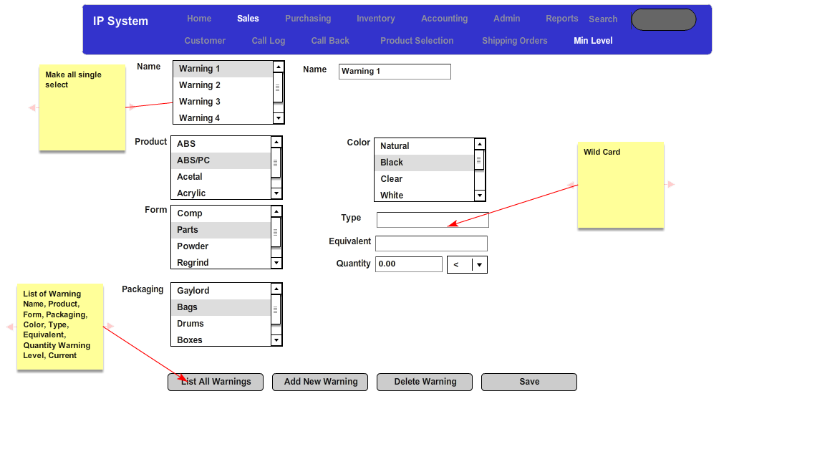

## Inventory

The first purpose of this section is to allow the inventory agents to take items from purchase orders and arrange proper transport (i.e. put them on transportation orders), receive the items into the warehouse and adjust the current available inventory in the warehouse(s) accordingly. The second purpose of this section is to allow the inventory personnel to take the transportation orders from the salesmen, print the proper documentation, adjust inventory accordingly and, if needed, adjust the actual items on the transportation order. The third purpose is to give the inventory personnel the ability to print various inventory management reports along with bulk printing the shipping orders, bills of lading and labels.

### Select Purchase Orders

The purpose of this form is to allow the inventory personnel to select purchase orders and create shipping orders from the products contained within the purchase order.

#### Fields

1. Radio Selection:
   1. Purchase Orders Without Shipping Orders: If this is selected, the search routine will contain only those purchase orders which have products that have not been assigned to a shipping order. The default for the radio selection is for this item to be selected.
   2. Purchase Orders with Shipping Orders: If this is selected, the search routine will contain only those purchase orders which all of the products have already been assigned to shipping orders.
   3. All Purchase Orders: If this is selected, the search routine will contain all purchase orders.
2. Start Date: This will be a date field relating to the date that the purchase order is going to be ready. The default for this field is the current date minus one business day.
3. End Date: This will be a date field relating to the date that the purchase order is going to be ready. The default for this field is the current date.
4. Purchase Orders In Select: This is the result of the search for purchase orders. The fields are described below.
   1. Purchase Order Number: The identifier which relates to the purchase order.
   2. Vendor: This is the vendor name from which the products have been made.
   3. Date Ready: This is the date the product will be ready (i.e. date for pickup).
   4. Delivery Location: This is the location which the products will be delivered to.

#### Buttons

1. Search: Given the selections above, this button will search for the available records and display them in the Purchase Orders in Selection grid
2. Edit Existing SO/BL: This button will display the “Inventory Select Shipping Order” screen.
3. Create New SO/BL: This button will take the selected purchase orders, create a new shipping order and place the user in the “Create Shipping Order Header” screen

#### Form

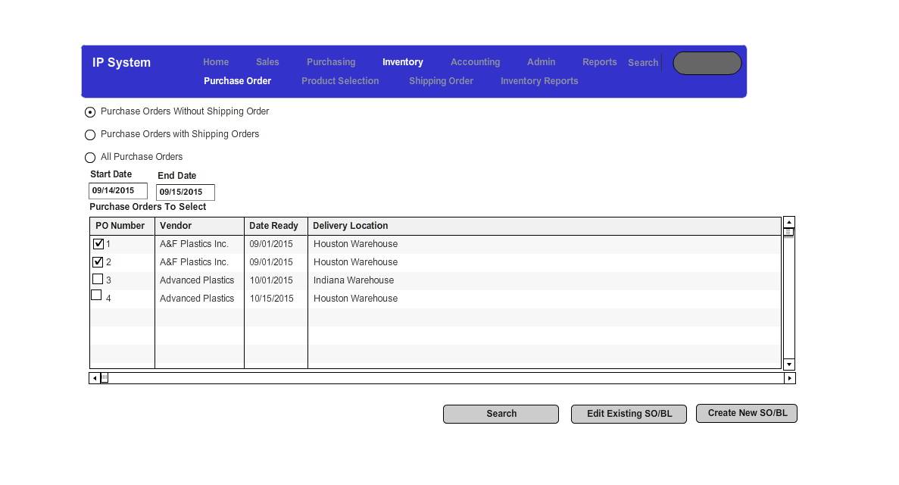

### Select Existing Shipping Order Screen

The purpose of this screen is to allow the user to select an existing shipping order and, ultimately, add items from the purchase orders selected. From this screen, the user will select an existing shipping order and when he/she is sent to the “Inventory Edit Shipping Order Header” screen, he/she will see the items from the selected purchase order(s) in the items available to select grid.

#### Buttons

1. Cancel: This button will close the existing form and send the user back to the previous screen.
2. Confirm: The user will select a specific shipping order and the user will be sent to the “Inventory Product Selection” screen.

#### Form

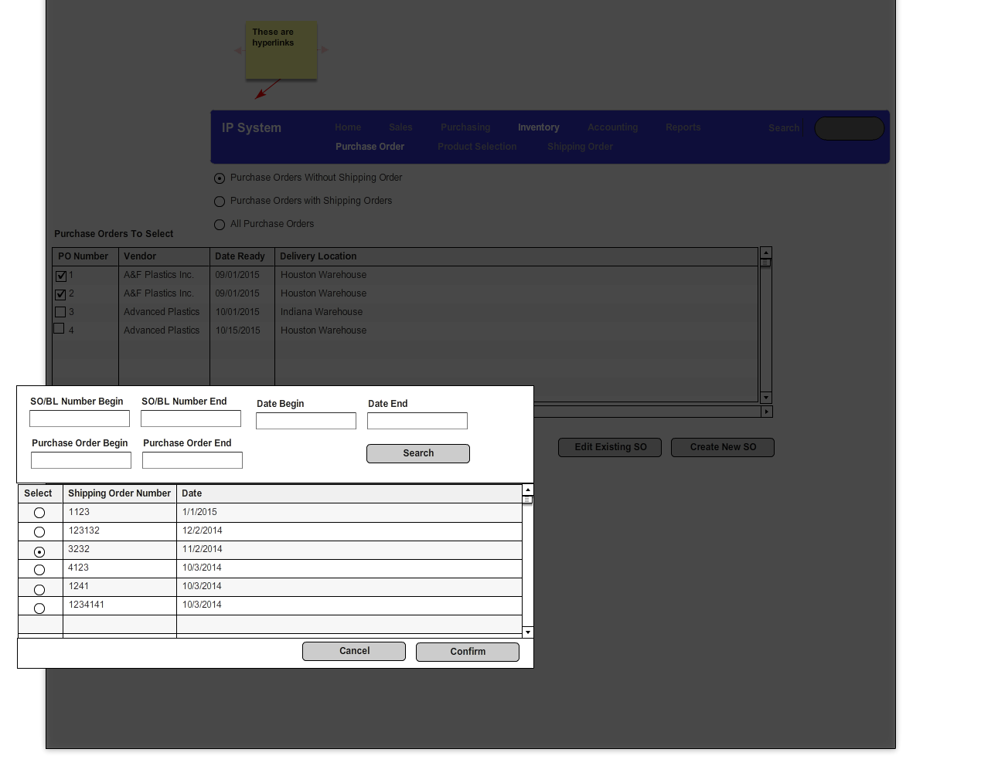

### Inventory Shipping Order Header

The purpose of this is to allow the inventory personnel to edit the header information of the transportation orders.

#### Fields

1. Shipping Order Printed: This is meant to define if a shipping order has been printed for this transportation order. By default this is unchecked. If a shipping label has been printed for this transportation order, this becomes checked. The shipping label is printed from the Inventory Reports screen. However, the user may uncheck this if he/she needs to reprint it. This can happen if product is added to the shipping order prior to shipment.
2. Bill of Lading Printed: This is meant to define if a bill of lading has been printed for this transportation order. By default this is unchecked. If a bill of lading has been printed for this transportation order, this becomes checked. The shipping label is printed from the Inventory Reports screen. However, the user may uncheck this if he/she needs to reprint it. This can happen if product is added to the shipping order prior to shipment.
3. Received In Inventory: If this transportation order is to ship to one of the Independent Plastics warehouses and the item has been received into inventory, the user would click this. Once this has been completed, the underlying inventory items would need to be updated accordingly.
4. Return To Vendor: This is checked if the item is being returned from the customer to Independent Plastics and the vendor is willing to accept the items.
5. Return To Warehouse: This would be checked if the item is being returned from the customer to Independent Plastics and the vendor is not willing to accept the items.

#### Buttons

1. Create Shipment Email: If this is a shipment to a customer, the inventory personnel should be able to click this button and have it automatically generate an email to the salesmen stating that the products have been shipped to their customers.
2. Product Selection: This button will take them to the inventory product selection page with this transportation order selected.
3. Delete Shipping Order: This will delete the transportation order. However, if a transportation order has already been logged as shipped to a customer or from a vendor, the transportation order cannot be deleted.
4. Save Shipping Order: This will save all items on the shipping order/transportation order.

#### Forms

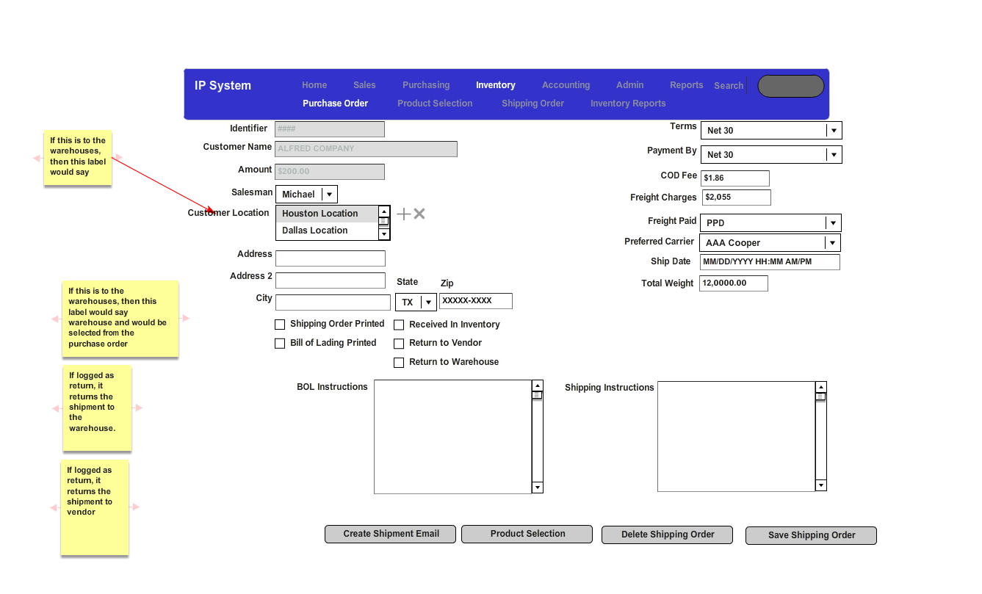

### Inventory Product Selection

The purpose of this screen is to allow the inventory personnel the ability to edit the products on an existing transportation order from a salesman or add products to a transportation order from various purchase orders. There are various reasons why the products may need to be altered on a transportation order even from a salesman but one of the most common reasons is that some of the product has been damaged in the warehouse. For example, the salesman wants 20 bags of a given inventory item but 1 of the bags was broken when they were storing the product.

#### Fields

1. Products On PO/SO: These are the products that are on the purchase order and can be placed on the transportation order
2. Products on Shipping Order: These are the products which are currently on the shipping order.

#### Buttons

1. Delete Product From SO: This will delete the selected products from the shipping order
2. Edit Product From SO: This will bring up the “Inventory Add/Edit Products” screen with the inventory items selected in the “Product In Shipping Order” grid
3. Add Products To Shipping Order: This will bring up the “Inventory Add/Edit Products” screen with the inventory items selected in the “Product In PO” grid
4. Save SO: This will update/save all of the inventory items in the “Products In Shipping Order” to the selected shipping order.
5. Create New SO: This will take the products in “Products In Shipping Order” and add them to a new shipping order along with sending the user to the Inventory Shipping Order Header screen.

#### Form

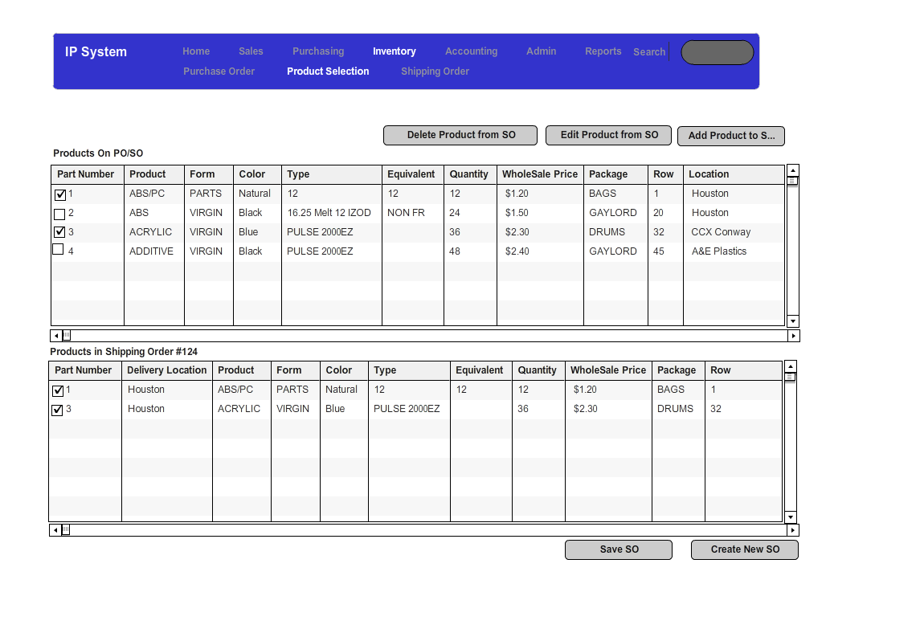

### Inventory Add/Edit Products

#### Buttons

1. Cancel: Cancels the changes and sends the user back to the prior screen.
2. Confirm: Saves the change to the inventory items on the transportation order.
3. Create Certificate: This creates the certificate in the reports section and saves the PDF to the line item of the transportation order.
4. Weights: This will bring up the Inventory Weights screen which will allow the inventory personnel to enter the weights for this line item.

#### Forms

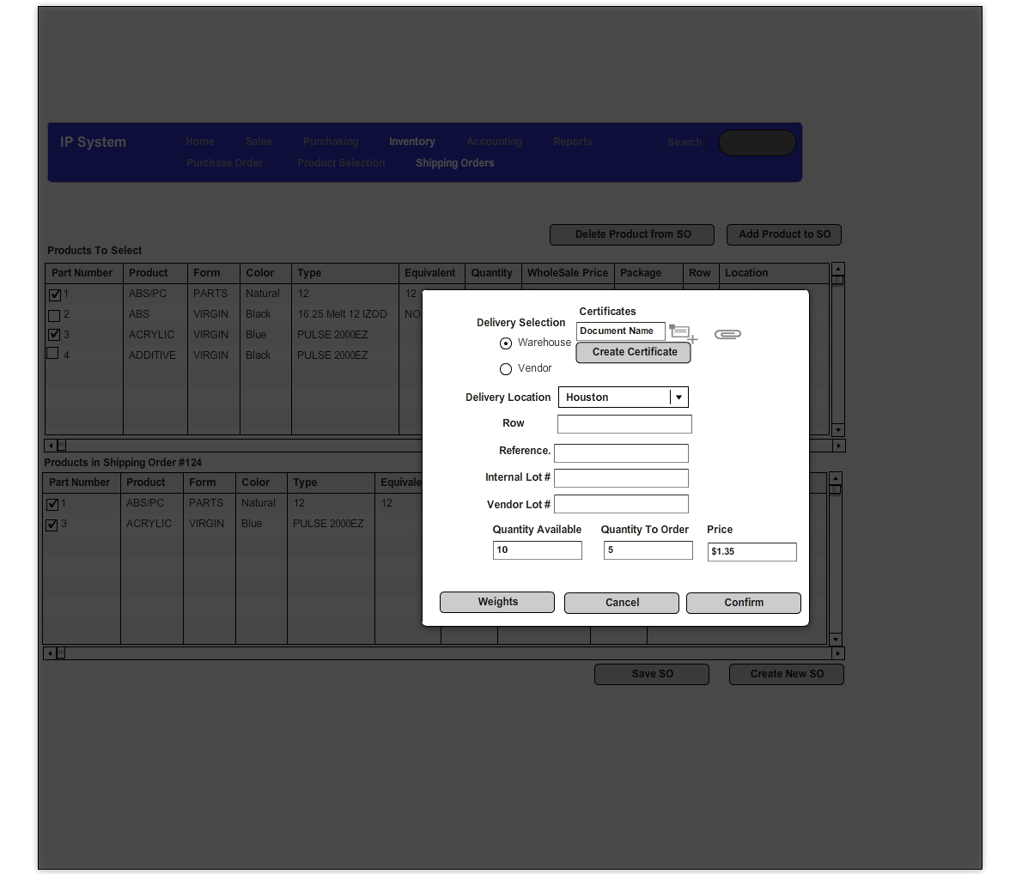

### Inventory Weights Screen

The purpose of this screen is to allow the user to enter a series of weights which define how the inventory items are to be placed on the truck when shipped.

#### Buttons

1. Cancel: Cancels the entry and returns the user to the previous screen.
2. Confirm: Saves the weights to the transportation order for this selected line item.

#### Forms

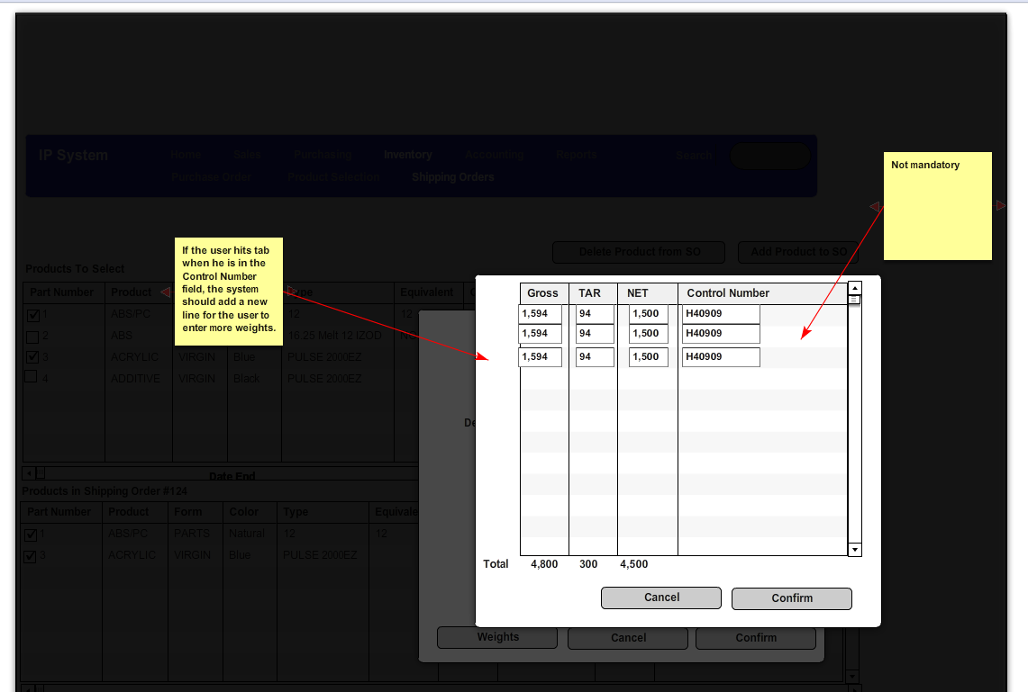

### Inventory Reports

The purpose of this screen is to allow inventory personnel to print the various reports required to manage the warehouse and transport the transportation orders.

#### Fields

1. Start Date and End Date: These refer to the shipment date of the transportation orders
2. Who Has: Inventory Person in Control of the Transportation Order

#### Buttons

1. Search: Will return all transportation orders with a shipment date between the start and end date and are to be delivered or shipped from the location.
2. View: This will view the pick list or ship list for the selected transportation orders.
3. Print: This will print the pick list or ship list for the selected transportation orders.
4. Save SO/BL: This will save the selected transportation orders with the status of the various check boxes (i.e. Shipping Order Printed, Adjust Inventory, etc.)
5. Print Labels: This will print the labels (see reports) associated with the selected transportation order.
6. Print Bill of Lading: This will print the bills of lading (see reports) associated with the selected transportation order.
7. Print Shipping Orders: This will print the Shipping Orders (see reports) associated with the selected transportation order.

#### Forms

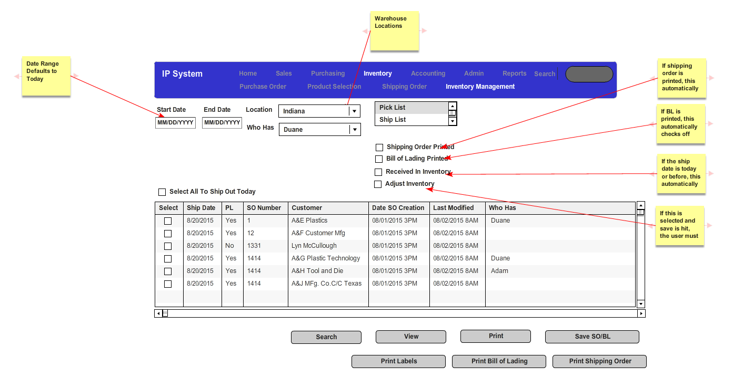

## Accounting

### Shipping Order Selection

This is meant to allow the accounting personnel to select the shipping orders for which they want to print invoices for. Due to the nature of invoicing within Independent Plastics, most invoices will be based on a single shipping order.

#### Buttons

Create Invoices: This will take the selected shipping orders to the invoices screen

#### Form

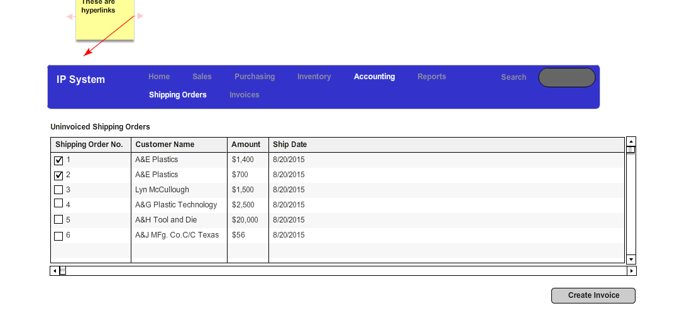

### Invoices

This screen allows the user to print the invoices based on the shipping orders selected.

#### Buttons

Save Invoices: This will save the information for the invoice

Print Invoices: This will print the invoice as displaying in the Invoice Reports.

#### Form

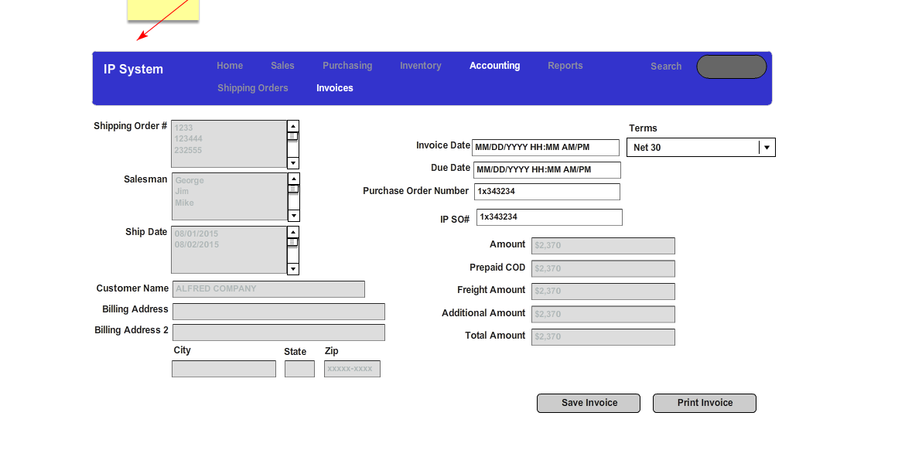

## Reports Form

### Report List

The purpose of this form is to allow the user to print one or many of the general reports. The reports in this screen are listed below:

1. CLEADING: Leading Customers By Volume
2. COGFIND: Material Shipped By Customer
3. FRNKA: Sales to Individual Customers By Material
4. INVSUM: Sum of Shipping Orders Total Price By Ship Date By Salesman
5. MIKE1: Gross Profit By Customer and Salesman Report
6. SALES18D: Gross Profit Report
7. INCOTT: Summary of the Cost on Inventory In the Warehouses
8. INVCHK: Shipping Orders by Date

#### Buttons

1. View: View the selected report over the given date range
2. Print: Print the selected reports over the given date range

#### Form

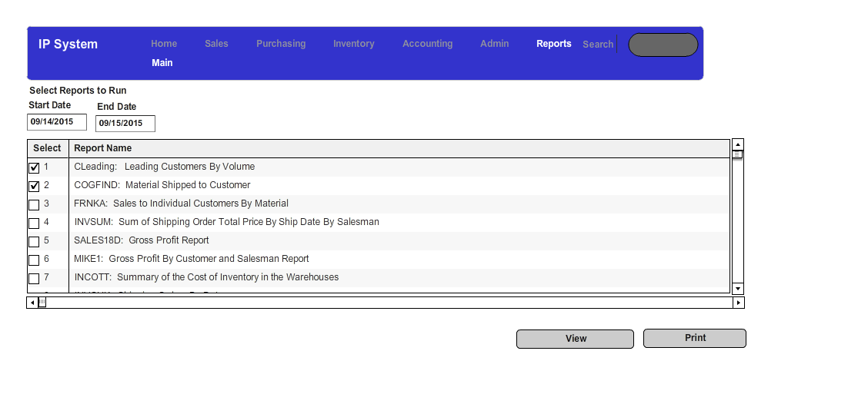

## Admin

The purpose of this section is to allow the users the ability to add items to generic lookup tables, add users and change user rights

### General Dropdowns

The drop down would define the general look up tables which the user would want the ability to add or delete records from.

#### Fields

The dropdown would be filled with the following look up tables which have only an identifier and a descriptive field. The active field will indicate if the record will still be displayed in the relevant drop down. The reference tables are identified below:

1. Packaging
2. Form
3. Products
4. Credit
5. Freight Carriers
6. Time Zones
7. States
8. Types of Contacts
9. Call Types
10. Types of Sales
11. Freight Paid
12. Payment Terms

#### Buttons

If a record has already been used to define a business relationship, shipping order or purchase order, it cannot be deleted and must be made inactive instead.

#### Form

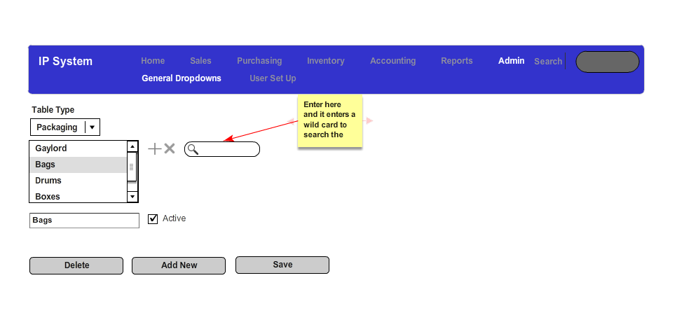

### User Setup

This screen is meant to allow the user to set up users with user rights. The user rights are as follows:

1. Management: Access to all screens including user set up
2. Sales: Access only to the sales screens
3. Purchasing: Access only to the purchasing screens
4. Inventory: Access only to the inventory screens
5. Accounting: Access only to the accounting screens.
6. Reporting: Access only to the reporting screens
7. Admin: Access only to the admin screens.

A user can have multiple rights. For example, if the a user has sales and purchasing rights, he/she has rights to the sales and the purchasing screens

If a user is inactive, his/her rights are suspended.

#### Buttons

1. Reset Password: This will send an email to the user which will reset his password to the password he/she chooses.
2. Add New: Add a new user. The default is active without any rights.

#### Form

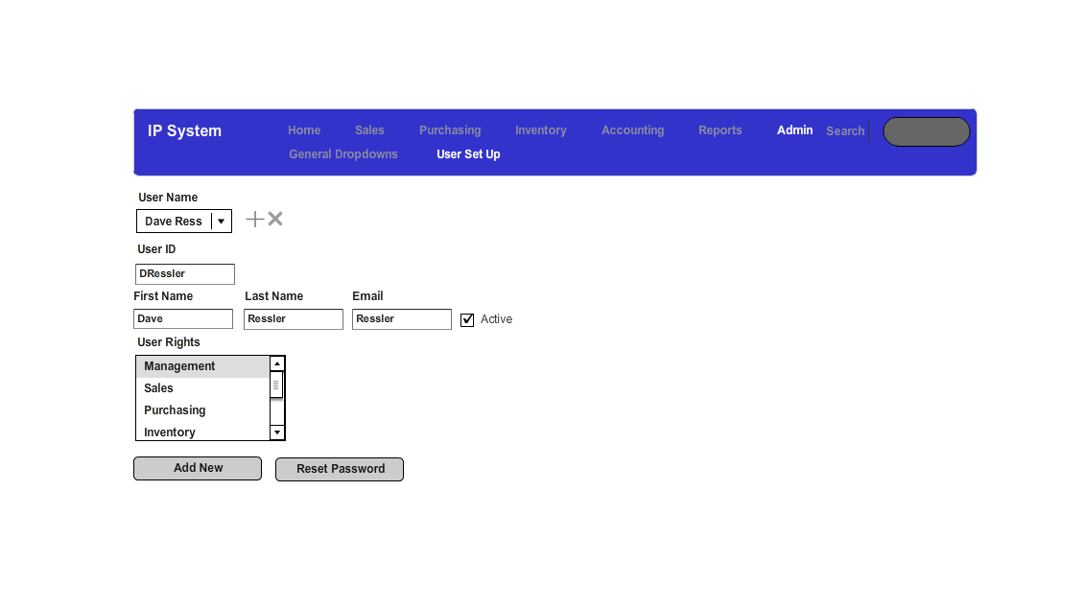

# Reports

All of the reports from the system have been defined below.

## Inventory Picklist / Shiplist

### Description

The report is meant to display a list of all inventory items on all transportation orders to be shipped within a given date range. This is meant to give the inventory personnel a list of items they need to validate are ready for shipment.

### Report

The current pick list is below. If you look at this report, it is displaying that only one transportation order was to be shipped on 07/17/2015.

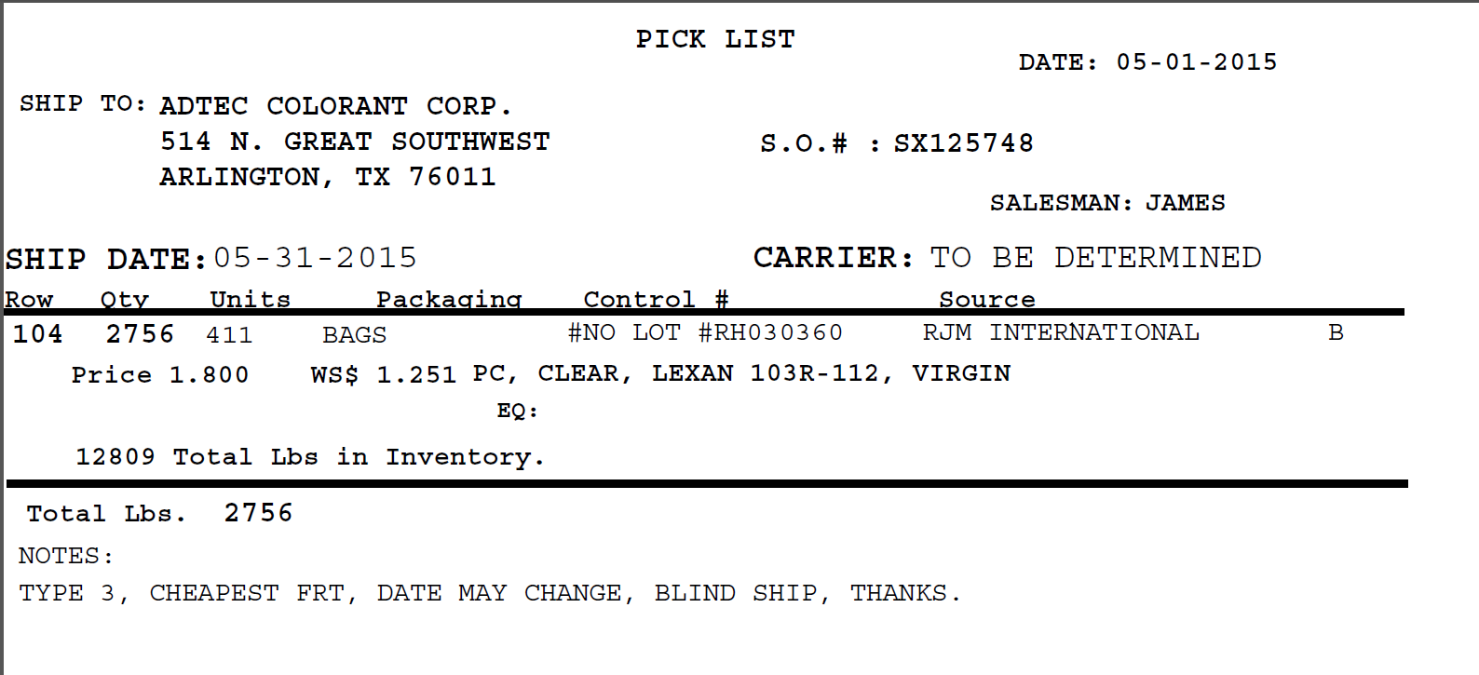

## Transportation Order Labels

### Description

These are labels that will be attached to the physical box. Each set of inventory items on transportation order will have its own label. The material description is the product, form and color of the set of inventory items to be shipped. The pounds is the quantity being shipped. The units are the number of packaging units being shipped.

### Report

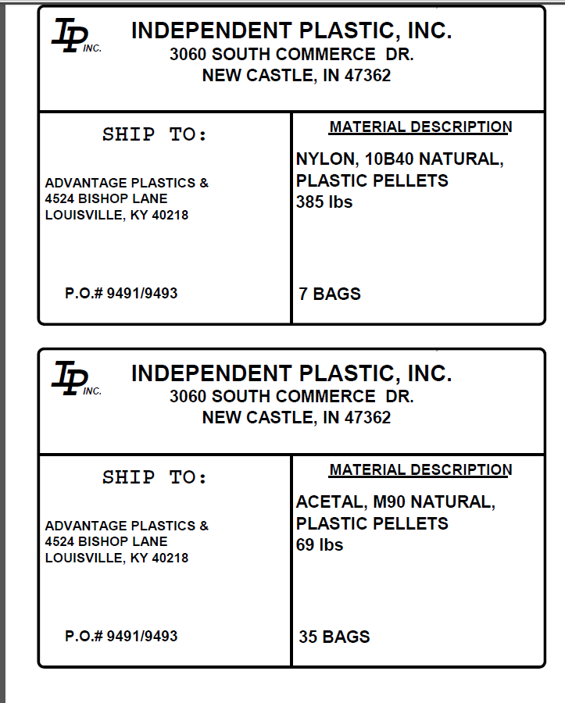

## Transportation Order Shipping Label

### Description

This is a sample shipping order. The “bill to” is the name of the billing name of the business relationship. The “ship to" is the name of the customer and the ship to address it he location which this is being shipped to.

### Report

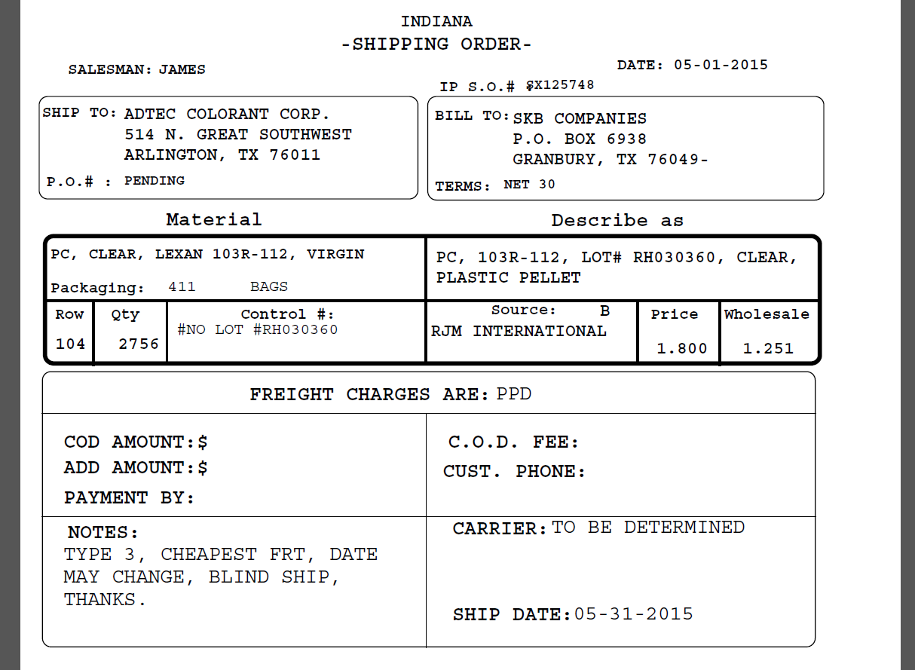

## Transportation Order Bill of Lading

### Description

A bill of lading is printed for every transportation order. It must be noted that consignee is always the customer or vendor Independent Plastics is delivering to while shipper is always Independent Plastics.

### Report

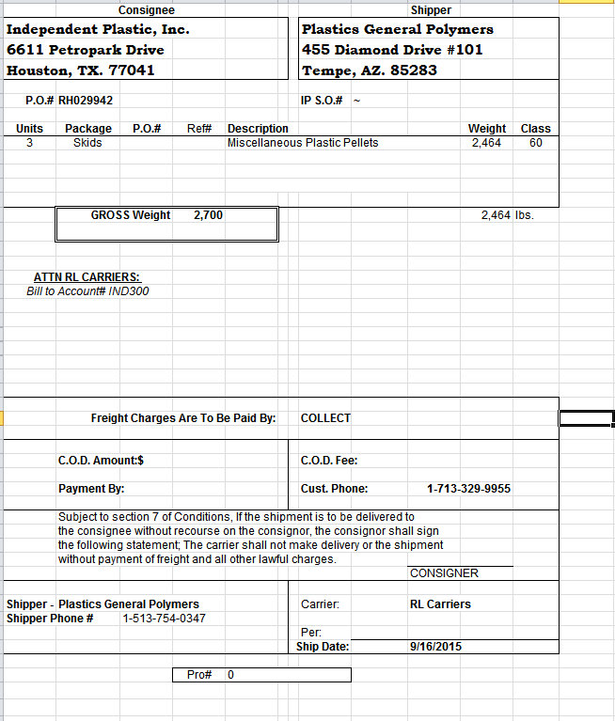

## Independent Plastics Certificate

### Description

The certificate is to be sent to the customer so this document should be addressed to (i.e. ATTN: ) to the customer name and the location of delivery for the transportation order. The Lot # is the Internal Lot Number of the inventory items of which this document applies. Currently, the salesman are generating this by hand.

### Report

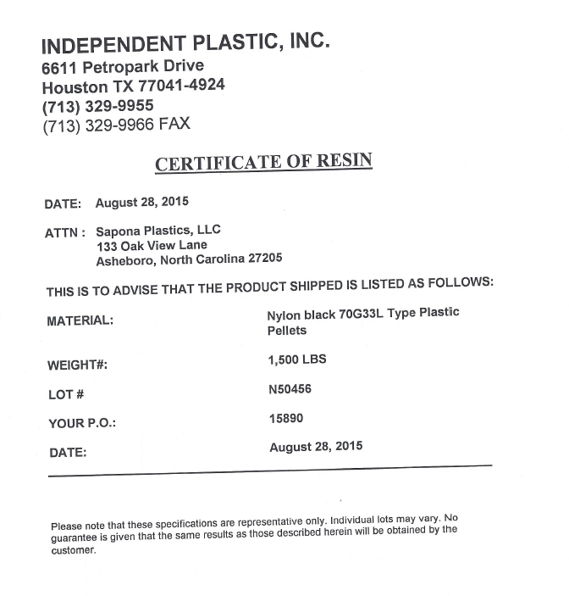

## Salesman Call Back Report

### Description

This will be a very simple report which given the date range selected, the report will display the customer to be called back and the call back message.

### Report

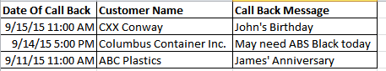

## Purchasing Level Report

### Description

This is the minimum level report which details what products are below the minimum levels set in the purchasing minimum level screen The current quantity is the total quantity that is available as of the running of the report, the quantity minimum level is the level set within the aforementioned screen and the last modified is the last time that the inventory level had been adjusted.

### Report

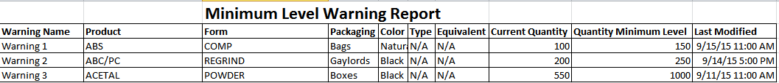

## Accounting Invoice

### Description

The shipped column is the sum of the quantity for the set of inventory items. The unit price is the sale price and the net is the unit price multiplied by the units. The subtotal is the sum of all items on the transportation order(s). Typically, each transportation order will have one invoice but there are times when multiple transportation invoices would be on one invoice.

### Report

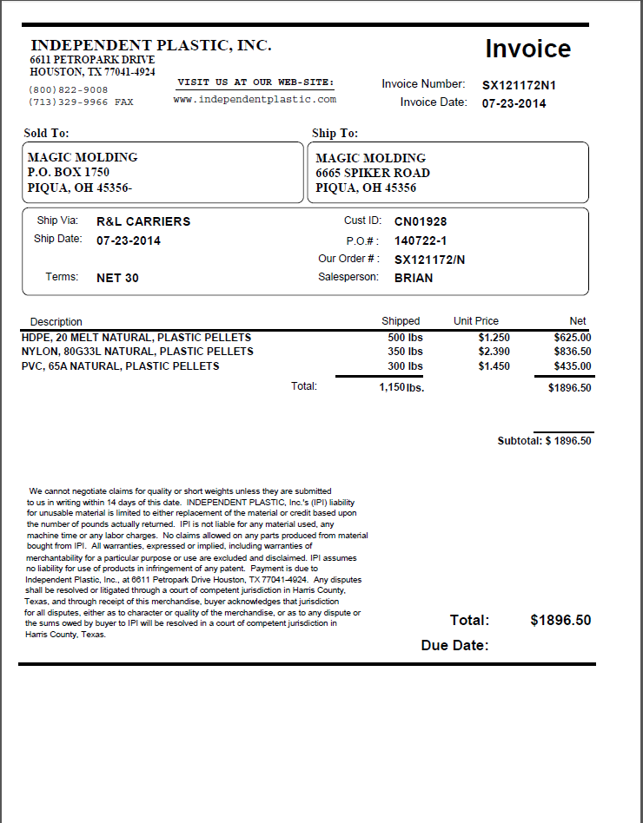

## Sales 18D: Gross Profit Report

### Description

This takes all transportation orders within a given date range and calculates the gross profit for all of those orders. It sorts the transportation orders by salesman. The parameters on the report that need defining are listed below:

1. Total Cost: This is the quantity times the wholesale purchase price for the given set of inventory items.
2. Freight Out Amt: This is the quantity times the freight cost on the transportation order being sold to the customer.
3. The total price is the sale price multiplied by the quantity.

### Report

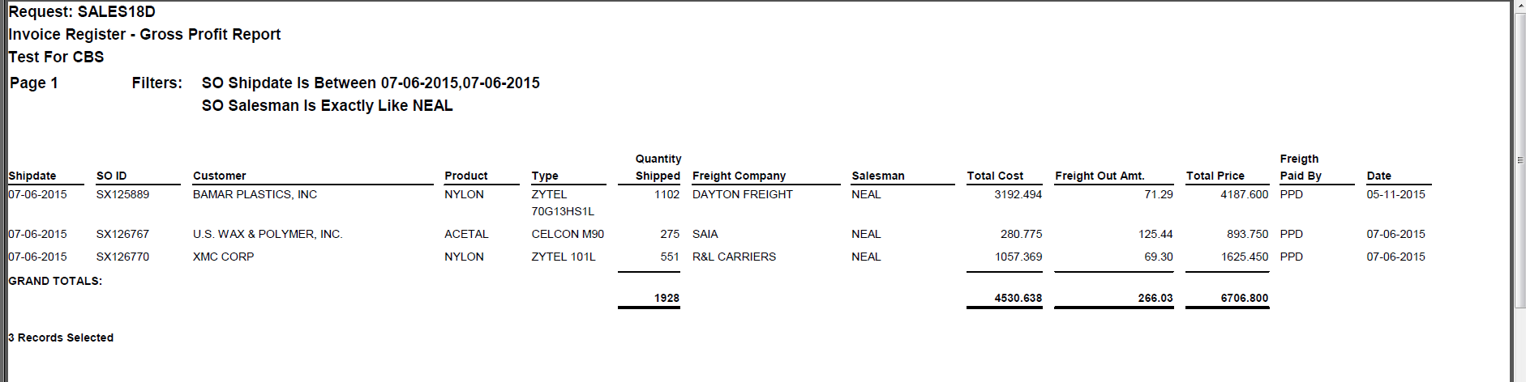

## INVSUM: Sum of Shipping Order Total Price by Ship Date By Salesman

### Description

This is a report of the total dollars by salesman by date. The total dollar is defined as the sum of the quantity times the sale price of all items sold on a given date by a given salesman.

### Report

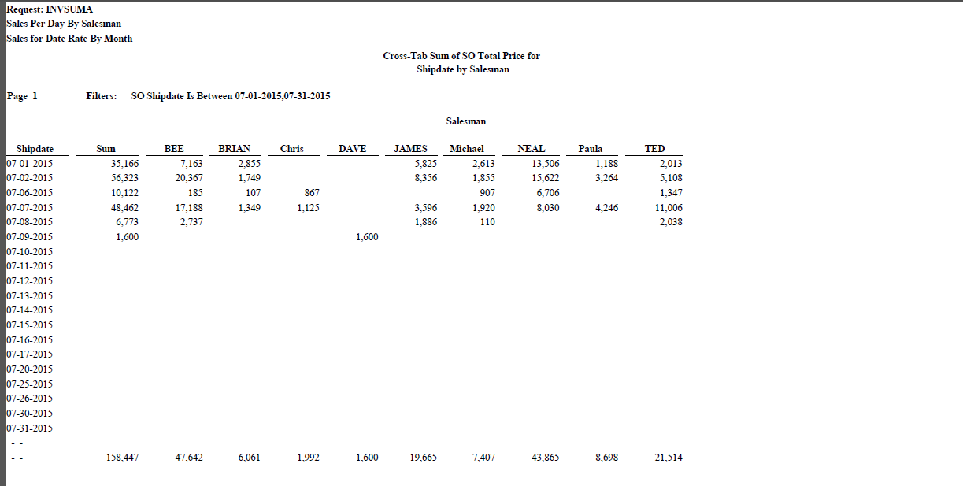

## MIKE1: Gross Profit By Customer and Salesman Report

### Description

The Mike 1 report is very similar to the Gross Profit Report but it adds on the dimension of the customer to which the product is being sold to. Essentially, this is a report of the gross profit by customer by salesman by date.

### Report

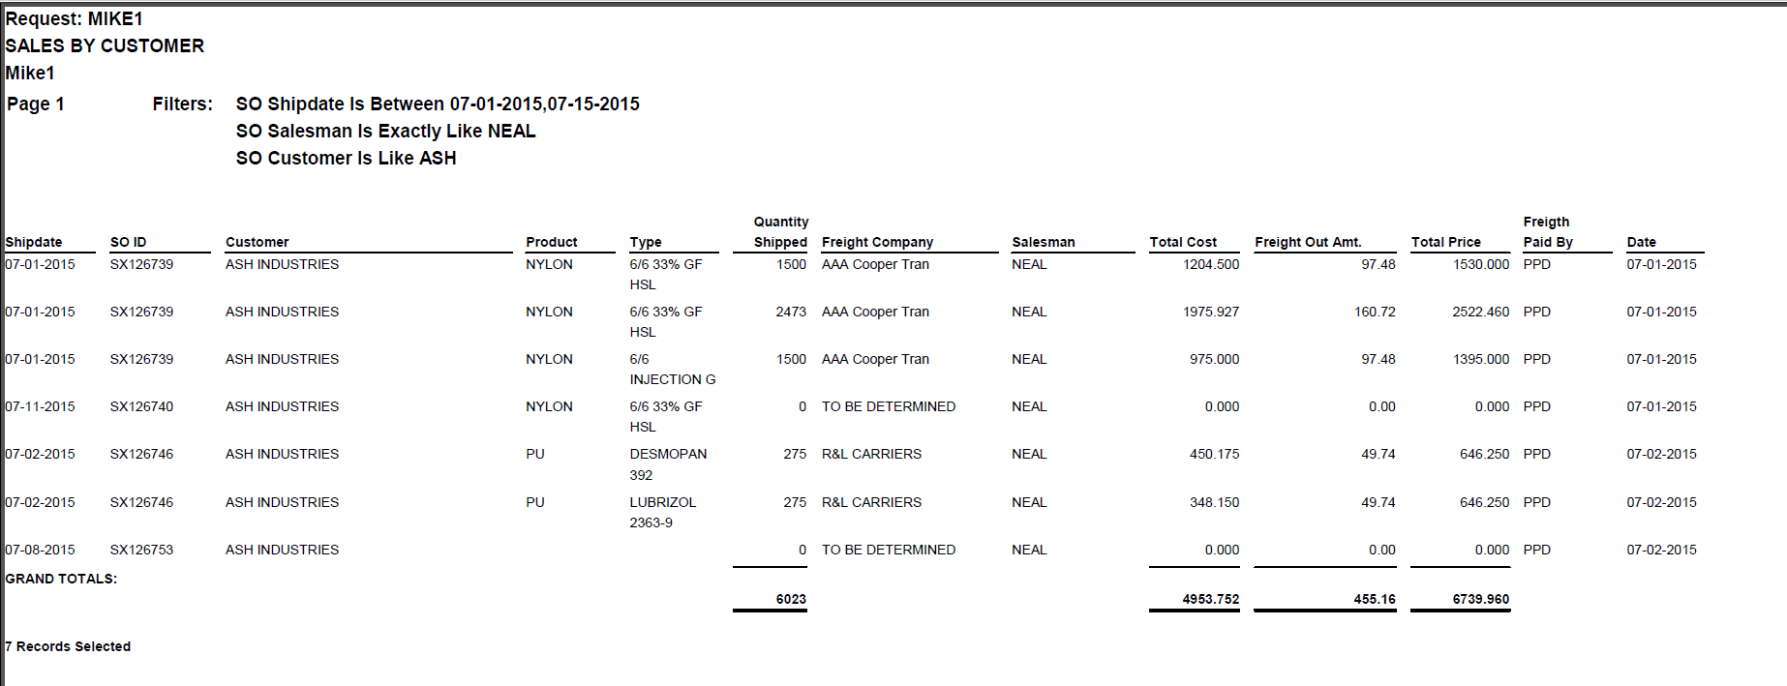

## CLEADING: Leading Customers by Sales By Volume

### Description

This report is intended to determine which customers generate the most sales and volume. The fields of interest are below:

1. The Total Price is the quantity times the sales price
2. The Total Cost is the quantity times the wholesale price
3. The Quantity Shipped is the total quantity shipped to this customer.

### Report

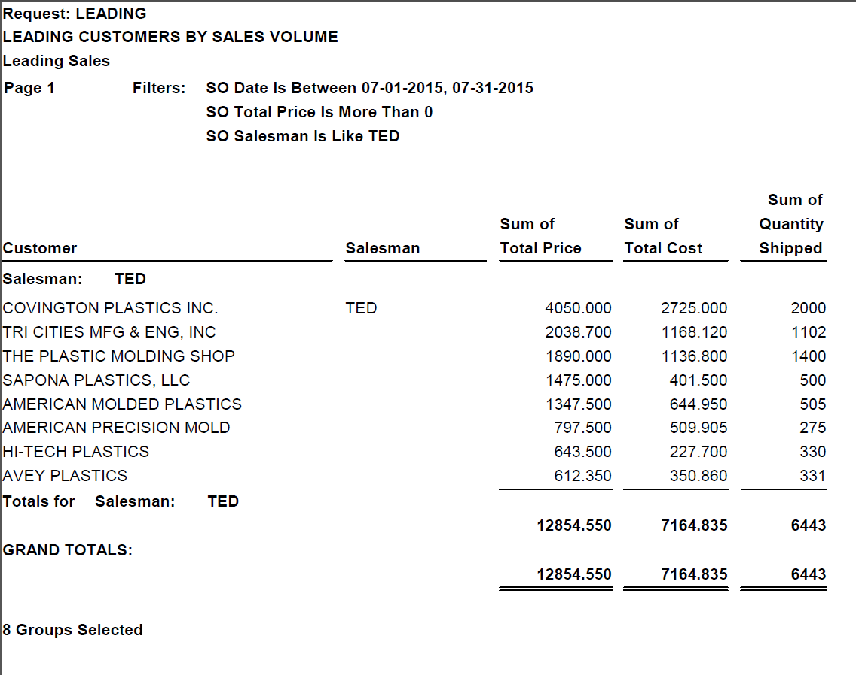

## FRNKA: Sales to Individual Customers By Material

### Description

This report displays the quantity of each inventory item shipped and the price of these materials. The ship from column should be N if the product shipped from the Indiana warehouse, H if it shipped from the Houston warehouse, and V if it shipped directly from the vendor. The total price is the quantity times the wholesale price.

### Report

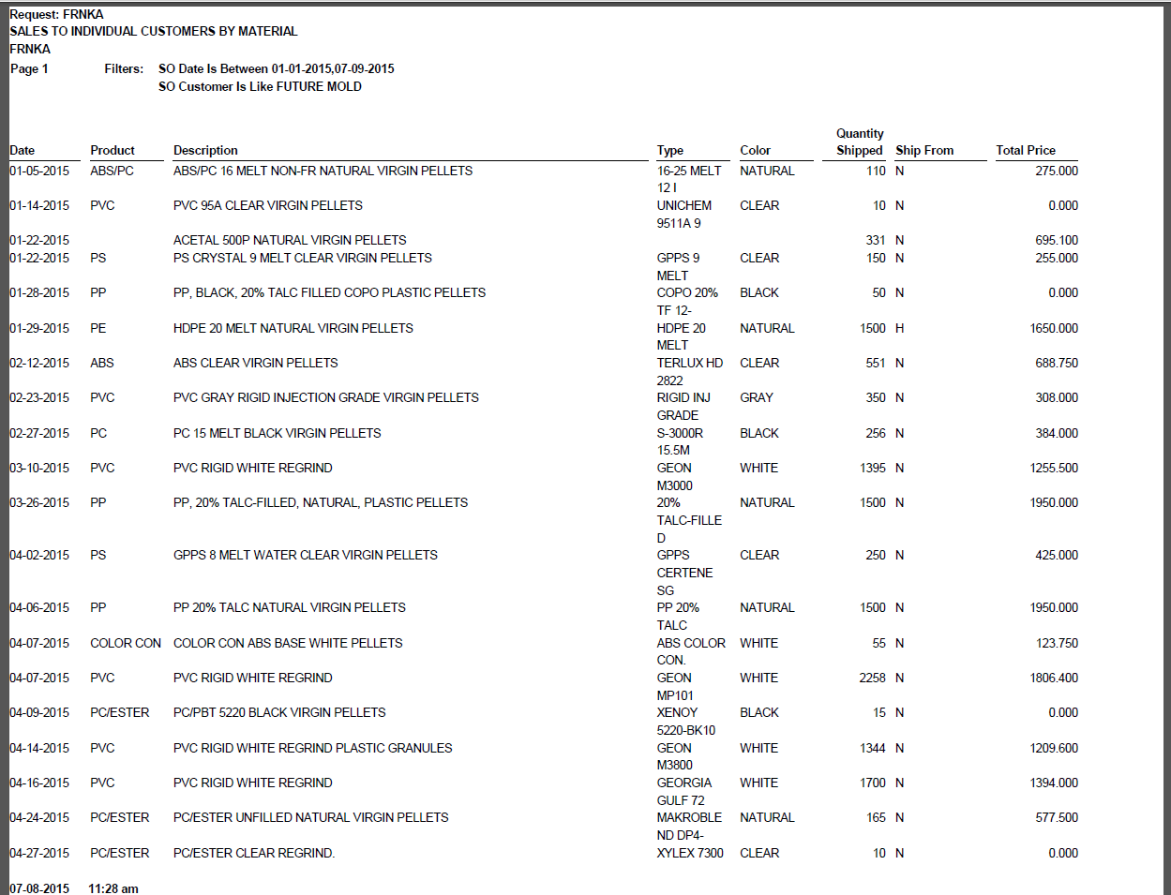

## COGFIND: Material Shipped to Customer

### Description

This report displays the total material (inventory items) shipped to each customer by date. The fields of interest are below:

1. Price is the wholesale price
2. Freight In is the freight cost to get it to the warehouse.
3. Total Cost is the quantity times the price plus the quantity times the freight in.
4. The total price is the quantity times the sale price
5. SO ID is the shipping order id. In the terms of this system, this would be the transportation identifier and would be a number.

### Report

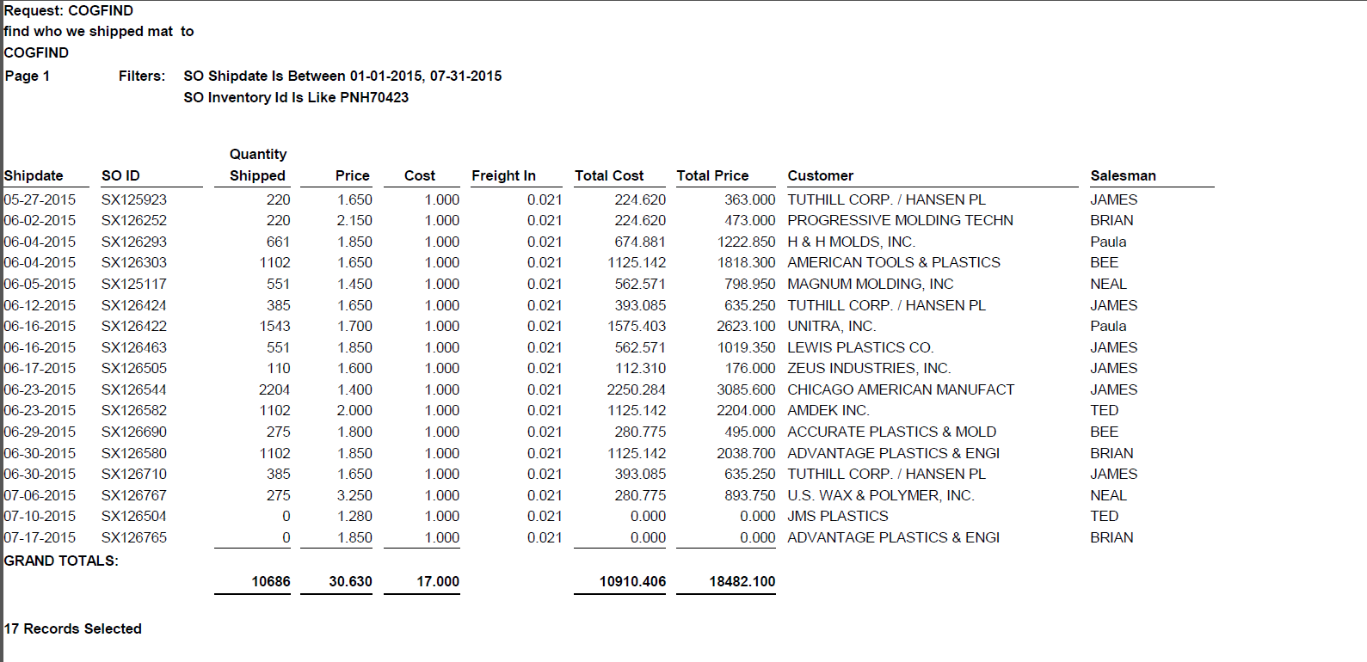

## INCOTT: Summary of the Cost of the Inventory in the Warehouses

### Description

This report is meant to display the cost of each item in the warehouse. It does so by summing the quantity by product (rows) and form (columns headers). The report only shows the items actually in the warehouses. This report should have one page for Houston and another page for Indiana.

### Report

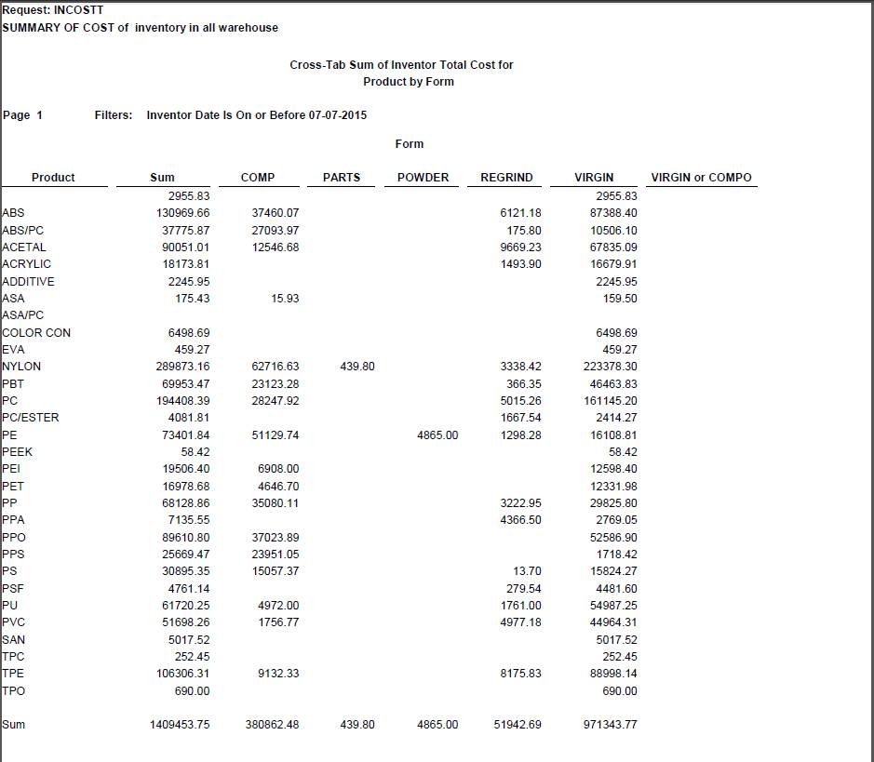

## INVCHK: Shipping Orders By Date

### Description

This report displays the shipping orders by date. The total price is the sum of the quantity times the sale price for the entire shipping order.

### Report

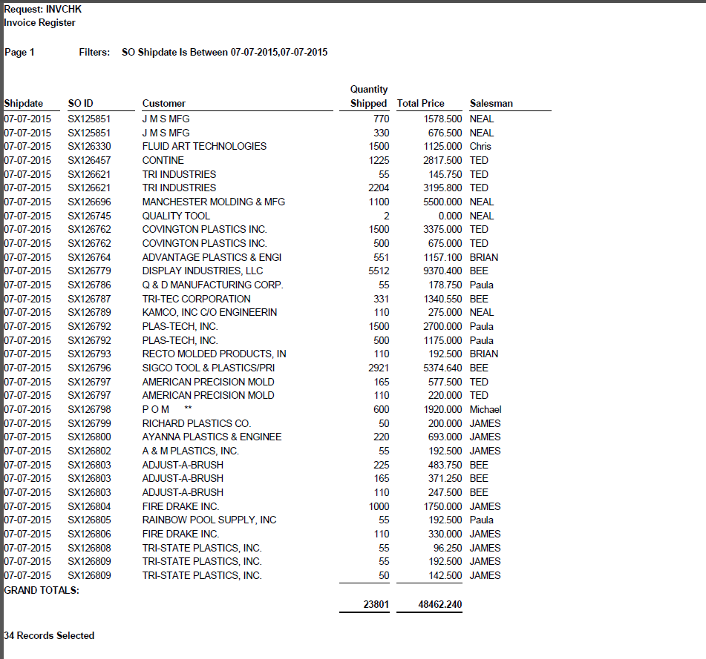

## Row Report

### Description

This report displays the current locations of all items in inventory. If inventory items have been received into inventory and have not been shipped out, they would be in a given location (i.e. row) within the warehouse.

### Report

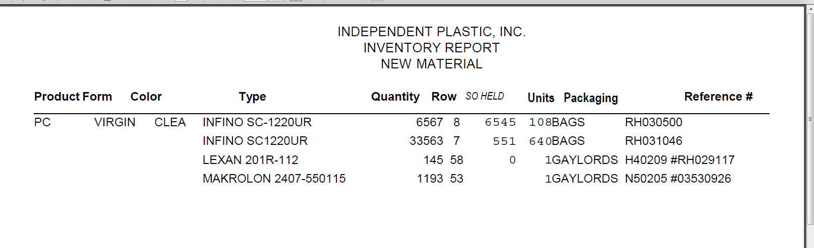

## Weight Report

### Description

This report displays the weights assigned to inventory items on a given transportation order.

### Report

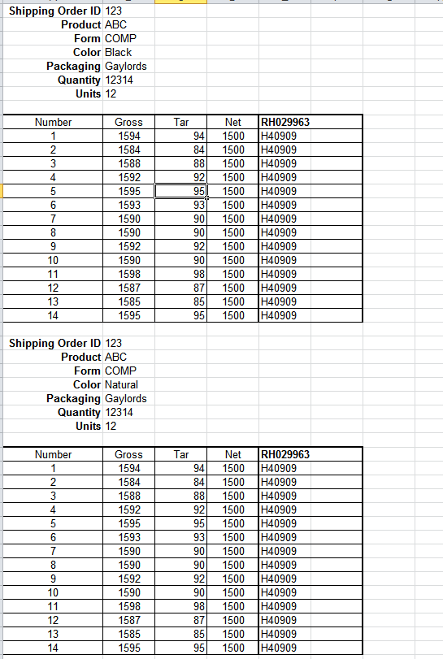

# Data Import

The current system is in a Fox Pro database. All of the data from the Fox Pro database will need to be imported into the new system. A backup of the production version of the Fox Pro database and the application has been provided in an Oracle Virtual Box Virtual Machine.

# Testing and User Acceptance

Although all systems will be tested by Custom Business Software, the system will also undergo a 1 week user acceptance period where Independent Plastics will test the existing system. This testing will not only test functionality but will also test that the existing data has been imported correctly.

# Standards

This document assumes that the following standards are used throughout the design of Jezebel.

## Target user

This design assumes that the target user will be an employee of SAS. Therefore, since the application is not client-facing, there’s no special consideration for usability and ease of use of a broad spectrum of users. The design assumes that internal SAS users would use the system and that they are an intermediate computer user that understand how to use web-based forms.

## Responsive design

In this scope of work, Independent Plastics will only be designed for use on the desktop version of Chrome. However, the technology will be such that in future phases of the development, that additional form factors, such as a tablet, or mobile devices can easily be added.

## Data grid filtering and sorting

All data grids will have the following standard behavior for all columns in the data grid.

1. 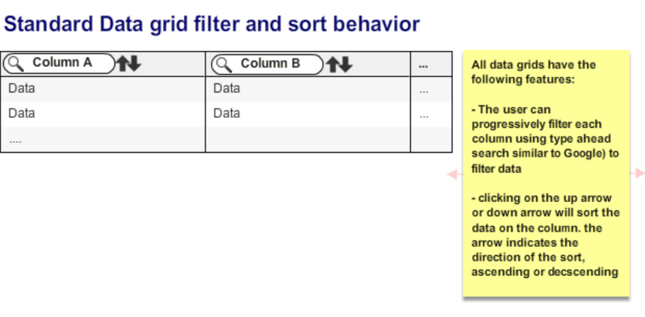When a user types in a search box in a data grid column heading, the data will filter dynamically like Google’s type ahead search.
2. When a clicks on the up arrow or down arrow the data in the data grid will sort the data on the column. The up arrow indicates ascending (A-Z) and down arrow is descending (Z-A).

## Error handling

All errors will show a standard pop-up error message. All errors will also be logged in an error log for the systems administrator to review and use for troubleshooting. The error log will log the time and date of the error along with the user ID and function causing the error.

## Formatting of fields

1. All fields that represent money will be right justified, comma a separator, a leading dollar sign and two decimal points like this $1,234.56
2. All quantity fields will be right justified a comma separator, and no decimal, like this: 9,999 unless otherwise specified.
3. All date fields will be displayed as MM/DD/YYYY unless otherwise specified.

## Operator Selections

Dropdowns that identify which operator is to be used will have the following operators:

1. Greater than
2. Greater than or equal to
3. Less than
4. Less than or equal to
5. Equal

## Time Zones

The allowable time zones are:

1. PST: Pacific Standard Time
2. MST: Mountain Standard Time
3. CST: Central Standard Time
4. EST: Eastern Standard Time

## Days of the Week

The allowable days are identified below and if placed in a list box/combo box, these items should be in the below stated order.

1. Sunday
2. Monday
3. Tuesday
4. Wednesday
5. Thursday
6. Friday
7. Saturday

## Calculated fields

In the Mockflow design, when a field is grayed out, it indicates that the field is calculated by the system, and not a field that is data entered.



## Buttons Warnings

All buttons that are adding, editing, confirming or deleting information from the database will request validation from the user of this action (i.e. warning message of “Please validate this action” with yes/no).

## Preview and Print capabilities

In all cases where a document can be previewed in Independent Plastics Application, such as a Purchase Order, or PO, that the document is rendered as a PDF and the built-in PDF tool on the computer (likely, Adobe Reader) will allow the user to print the document to the printer.

## Web Services

All requests for data will be handled through a web service. There will not be any direct connection from the web to the database.

## Azure Platform

The database, web services and the web site will be hosted on the Microsoft Azure platform.

## Excel Connectivity/BI

The system should be open such that MS Excel reports can be created on an as needed basis.

## Historical records

A complete history of data changes must be kept. Management will eventually need to be able to see who changed what records. Therefore, every table will have a corresponding historical table which will house any changes to the data. For example, if we have a sales table called SalesTable, we will have a corresponding HistSalesTable. This history table will have all of the same fields as the SalesTable but will also have an identifier called HistID. If the SalesTable has a change to a row, the current row will be placed in the Hist.SalesTable prior to the update.

## Drop downs and list boxes

If the field is a text, all drop downs and list boxes must be sorted alphabetically unless otherwise stated. If the field is a person’s name, the drop down is sorted alphabetically by the last name and then the first name.

If the field is a numeric or a date/time field, the field is sorted in descending order (i.e. 3,2,1 or 09/14/2015 09:00AM, 09/13/2015 05:00PM, 09/11/2015 05:00PM, 09/11/2015 09:00AM)

## Plus/Minus Icon

Any time that a plus/minus icon (see below) is next to a list box, then the user is sent to a modal screen which will allow the user to add or delete a record from the aforementioned list box. If a record is tied to a shipping order, then the user is not allowed to delete the record from the list box and/or the underlying table.



## State Fields

All states must have all of the 50 US States. Below is a list of all state abbreviations:

|  |  |
| --- | --- |
| US State: | Abbreviation: |
| Alabama | AL |
| Alaska | AK |
| Arizona | AZ |
| Arkansas | AR |
| California | CA |
| Colorado | CO |
| Connecticut | CT |
| Delaware | DE |
| Florida | FL |
| Georgia | GA |
| Hawaii | HI |
| Idaho | ID |
| Illinois | IL |
| Indiana | IN |
| Iowa | IA |
| Kansas | KS |
| Kentucky | KY |
| Louisiana | LA |
| Maine | ME |
| Maryland | MD |
| Massachusetts | MA |
| Michigan | MI |
| Minnesota | MN |
| Mississippi | MS |
| Missouri | MO |
| Montana | MT |
| Nebraska | NE |
| Nevada | NV |
| New Hampshire | NH |
| New Jersey | NJ |
| New Mexico | NM |
| New York | NY |
| North Carolina | NC |
| North Dakota | ND |
| Ohio | OH |
| Oklahoma | OK |
| Oregon | OR |
| Pennsylvania | PA |
| Rhode Island | RI |
| South Carolina | SC |
| South Dakota | SD |
| Tennessee | TN |
| Texas | TX |
| Utah | UT |
| Vermont | VT |
| Virginia | VA |
| Washington | WA |
| West Virginia | WV |
| Wisconsin | WI |
| Wyoming | WY |
| Commonwealth/Territory: | Abbreviation: |
| American Samoa | AS |
| District of Columbia | DC |
| Federated States of Micronesia | FM |
| Guam | GU |
| Marshall Islands | MH |
| Northern Mariana Islands | MP |
| Palau | PW |
| Puerto Rico | PR |
| Virgin Islands | VI |
| Military "State": | Abbreviation: |
| Armed Forces Africa | AE |
| Armed Forces Americas | AA |
| Armed Forces Canada | AE |
| Armed Forces Europe | AE |
| Armed Forces Middle East | AE |
| Armed Forces Pacific | AP |

# Project Assumptions

## Existing Technology Infrastructure

The current infrastructure is an application running under Windows XP and on a FoxPro database.

## Production Infrastructure

At a high level, this system would be a web based solution relying on Microsoft’s Cloud to provide the necessary up time. The languages used will be common technologies to enable the ease of finding programmers with the necessary technical expertise.

In detail, the new infrastructure will be a Microsoft Azure database and Microsoft Azure cloud based solution. The web pages would be written in HTML5 with a bootstrapped style sheets and JAVA script which would enable the system to be viewed on a mobile device such as an Android phone or iPhone. The back end of the system will be using C# web services on Microsoft’s Cloud Service and a Microsoft Azure SQL Server.

# Warranty

We will provide a 30 day warranty starting once each phase’s application changes have been accepted. All material bugs related to RYCIO development in the system will be fixed at no additional charge within this warranty.